

Republic of the Philippines
UNIVERSITY OF EASTERN PHILIPPINES
College of Science

Title Page
Catarman Dog Pound & Animal Shelter Management System

A Capstone Project

Presented to the Faculty
Of the College of Science
University of Eastern Philippines
University Town, Northern Samar

In Partial Fulfillment
Of the Course Requirements for the degree
Bachelor of Science in Information Technology

DALE MATTHEW Y. BONA
JOHN KENNETH L. LARON
Researchers

2025

Abstract
Title : Catarman Dog Pound & Animal Shelter
Management System
Researchers : Bona, Dale Matthew Y.
Laron, John Kenneth L.
Degree : Bachelor of Science in Information
Technology
Adviser : Emmanuel D. Santos,
School : University of Eastern Philippines
Year : 2025

This capstone project proposes the development of a "Catarman Dog Pound & Animal Shelter Management System," a comprehensive digital solution designed to streamline the operations of the local dog pound and animal shelter. The system aims to centralize the management of animalⅼinformation, facilitate adoption processes, track inventory, and provide robust user management functionalities for various stakeholders, including site administrators, veterinarians, and potential adopters. By automating key processes and providing real-time data access, the system seeks to enhance efficiency, improve animal welfare, and foster more effective community engagement in animal adoption

Table of Contents
Title Page 1
Abstract 2
Table of Contents 3
List of Figures 5
List of Tables 7
CHAPTER I 8
Introduction 8
Technical Background 8
Purpose and Description of the Project 9
Project Description 9
Objectives of the Project 11
General Objective 11
Specific Objectives 11
Scope of the Project 13
General Description of Business Requirements 13
Functional Requirements 13
Geographical Scope 15
Technical Specifications 16
Limitations 16
Significance of the Project 17
Definition of Terms 19
System and Technology Terms 19
Animal Welfare and Shelter Terms 21
CHAPTER II 23
Review of Related Literature and Studies 23
Related Literature 23
Foreign Literature 23
Local Literature 23
Related Studies 24
Foreign Studies 24
Local Studies 25
Matrix of the Literature 27
CHAPTER III 29
Methodology 29
Development Methodology 29
Requirements Specifications 31
Use Case Diagram 31
Relevance of the Technologies 34
Requirements Modeling 36
Input 36
Process 37
Output 37
Performance 37
Control 38
Security 38
Process, Interface and Data Modeling 39
Process Modeling 39
Context Diagram 40
Current System 40
Proposed System 41
Functional Decomposition Diagram 42
Event Diagrams 43
System Diagram 46
Interface Model 47
Data Modeling 60
Context Data Model 60
Key-Based Data Model 60
Fully Attributed Data Model 61
Data Dictionary 63
CHAPTER IV 73
System Implementation and Unit Testing 73
Implementation 73
Hardware Specification 74
Program Specification 74
Programming Environment 75
Front-End 75
Back-End 76
Deployment Diagram 76
Implementation Plan 76
Unit Testing 77
CHAPTER V 88
Summary, Conclusions and Recommendations 88
Summary 88
Conclusions 89

List of Figures
Figure 1. Water Fall Methodology Diagram 29
Figure 2: Use Case of Admin 31
Figure 3: Use Case of Staff 31
Figure 4: Use Case of Adopter 32
Figure 5: Use Case of Veterinarian 32
Figure 6: Context Diagram for Current System 40
Figure 7: Context Diagram for Proposed System 41
Figure 8: Functional Decomposition Diagram 42
Figure 9: Admin Event Diagram 43
Figure 10: Staff Event Diagram 43
Figure 11: Adopter Event Diagram 44
Figure 12: Veterinarian Event Diagram 44
Figure 13: System Diagram 46
Figure 14: Log in Form 47
Figure 15: Sign up Form 47
Figure 16: Admin Main Dashboard Page 48
Figure 17: Admin Animal Page 49
Figure 18: Admin Adoption Request Page 49
Figure 19: Admin Medical Record Page 50
Figure 20: Admin Inventory Page 50
Figure 21: Admin Billing Page 50
Figure 22: User Management Page 51
Figure 23: Admin Profile Page 51
Figure 24: Staff Main Dashboard 52
Figure 25: Staff Animal Page 52
Figure 26: Staff Adoption Request Page 53
Figure 27: Staff Medical Records Page 53
Figure 28: Staff Inventory Page 54
Figure 29: Staff Billing Page 54
Figure 30: Staff Profile Page 55
Figure 31: Veterinarian Main Dashboard 55
Figure 32: Veterinarian Animal Page 56
Figure 33: Veterinarian Adoption Request Page 56
Figure 34: Veterinarian Medical Records Page 57
Figure 35: Veterinarian Profile Page 57
Figure 36: Adopter Explore Page 58
Figure 37: Adopter Animal View Page 58
Figure 38: Adopter Adoption Request Page 59
Figure 39: Adopter Profile Page 59
Figure 40: Context Data Model 60
Figure 41: Key-Based Data Model 61
Figure 42: Fully Attributed Data Model 63
Figure 43: Deployment Diagram 76

List of Tables
Table 1: Technologies Used 12
Table 2: Technical Specifications 17
Table 3: Matrix of the Literature 29
Table 4: System Development Hardware Specification 34
Table 5: System Development Software Specification 34
Table 6: Roles 64
Table 7: Users 64
Table 8: Veterinarians 66
Table 9: Animals 66
Table 10: Impound Records 67
Table 11: Medical Records 68
Table 12: Feeding Records 69
Table 13: Adoption Requests 70
Table 14: Inventory 71
Table 15: Invoices 72
Table 16:Payments 73
Table 17: Activity Logs 73
Table 18: Software Requirements 75
Table 19: Minimum Requirements 75
Table 20: Recommended Requirements 75
Table 21: Rating Scale 79
Table 22: Testing the level of acceptability in terms of Performance 80
Table 23: : Testing the level of acceptability in terms of Information 82
Table 24: Testing the level of acceptability in terms of Efficiency 84
Table 25: Testing the level of acceptability in terms of Control and Security 86
Table 26: Testing the level of acceptability in terms of Economics 87
Table 27: Testing the level of acceptability in terms of Services 89

CHAPTER I

Introduction

Technical Background
The escalating global concern over stray animal populations and their welfare represents a multifaceted challenge with profound implications for public health, environmental sustainability, and community well-being. This issue is particularly acute in developing nations, where socio-economic constraints and inadequate animal management infrastructure often exacerbate the problem. The Philippines, with an estimated 12 to 13 million stray dogs and cats, faces a severe crisis that demands innovative, technology-driven solutions (Manila Standard, 2024; Senator Cynthia Villar, 2023; CARA Philippines, n.d.).
Traditional approaches to animal shelter management have relied heavily on paper-based record-keeping systems, manual data entry, and fragmented information storage. These conventional methods present significant operational challenges, including data inconsistency, difficulty in tracking animal histories, delayed decision-making, and compromised transparency. Furthermore, the widespread existence of unregistered and non-compliant animal facilities across the country underscores a critical gap between legislative mandates and practical implementation (Philippine Legal Research, 2024; Poe, 2024).
The advent of web-based management systems offers a transformative opportunity to address these systemic inefficiencies. Modern web technologies—including HTML5 for semantic structure, CSS3 for responsive design, JavaScript for dynamic interactivity, and robust server-side frameworks—enable the development of comprehensive, accessible, and scalable solutions for animal shelter operations. The integration of relational database management systems, such as MySQL, provides reliable data storage and retrieval mechanisms essential for maintaining accurate animal records, medical histories, and adoption tracking. Catarman, Northern Samar, presents a unique context for technological intervention. The municipality has demonstrated commendable commitment to animal welfare through initiatives such as the newly-constructed Animal Birth Control (ABC) center and regular "Pet Day" events conducted in collaboration with the Provincial Veterinary Office and local partners (Provincial Government of Northern Samar, 2025; The Philippine Animal Welfare Society [PAWS], n.d.). However, the absence of an integrated digital management system limits the potential impact of these efforts, necessitating the development of a purpose-built web-based solution.

Purpose and Description of the Project
The Catarman Dog Pound & Animal Shelter Management System (CDP&ASMS) is a comprehensive web-based application designed to modernize and streamline the operations of the Catarman Dog Pound and Animal Birth Control Center. This system addresses the critical need for centralized data management, transparent processes, and efficient resource allocation in animal welfare administration.

Project Description
The CDP&ASMS serves as an integrated platform that consolidates all essential shelter operations into a single, accessible interface. The system facilitates:
- Centralized Record Management: A unified database for storing and retrieving animal profiles, medical records, and stakeholder information
- Streamlined Adoption Processes: Digital workflow management for adoption applications, from submission through approval
- Inventory Oversight: Real-time tracking of shelter supplies, medications, and veterinary products
- Reporting and Analytics: Generation of operational reports to support data-driven decision-making
- Role-Based Access Control: Secure, permission-based system access for administrators, veterinarians, and staff members.
The system is architected using industry-standard web technologies:
Component | Technology | Purpose
Frontend Structure | HTML5 | Semantic document structure and content organization
Frontend Styling | CSS3 | Visual presentation, responsive layouts, and user experience
Frontend Interactivity | JavaScript | Dynamic behavior, form validation, and client-side processing
Backend Logic | PHP | Server-side processing, RESTful API development, and business logic
Database | MySQL | Relational data storage, query processing, and data integrity

Table 1: Technologies Used
This technological stack ensures cross-platform accessibility, robust performance, and maintainable codebase architecture. Additionally, the frontend integrates Chart.js for data visualization on the dashboard and jsPDF with AutoTable for PDF report generation.

Objectives of the Project

General Objective
To design and develop a web-based Record Management System for the Catarman Dog Pound & Animal Shelter that streamlines shelter operations, enhances record accuracy, and improves overall management efficiency. The system aims to address the challenges of manual and fragmented record-keeping by providing a centralized platform that supports secure data storage, transparent processes, and informed decision-making while optimizing animal tracking, strengthening compliance with animal welfare legislation, and facilitating coordination among shelter staff, veterinarians, and the community.

Specific Objectives
The project specifically aims to:
1. Design the System Architecture
- Develop a comprehensive data structure that supports the shelter's core operational requirements
- Establish efficient process flows for animal intake, care management, and adoption procedures
- Implement the system using appropriate programming languages and frameworks (HTML, CSS, JavaScript, PHP, MySQL)
2. Enable Comprehensive Profile Management
- Create and maintain detailed records for adopters, pet owners, and veterinarians
- Manage complete animal profiles including intake information, physical characteristics, and behavioral assessments
- Track comprehensive medical records encompassing vaccinations, treatments, surgeries, and medication schedules - Document adoption histories and outcomes for accountability and analysis
3. Incorporate Inventory and Reporting Capabilities
- Implement inventory tracking for essential shelter supplies including food, medications, and veterinary products
- Develop reporting tools to generate accurate and timely operational data
- Provide analytics functionality to support evidence-based management decisions
4. Implement Role-Based Access Control
- Establish secure authentication and authorization mechanisms
- Define appropriate access levels for administrators, veterinarians, and staff members
- Ensure data security and privacy through permission-based system architecture
5. Implement Billing and Finance Tracking
- Develop invoice generation for adoption and reclaim fees
- Enable payment recording with multiple payment methods
- Track financial transactions and generate billing reports
6. Maintain Activity Logging and Audit Trails
- Record user actions for accountability and security - Track system events with timestamps and IP addresses - Support compliance requirements through comprehensive logging
7. Evaluate System Acceptability
- Assess system performance in terms of response time and reliability
- Evaluate information quality regarding accuracy, completeness, and relevance
- Measure economic efficiency in resource utilization - Verify control mechanisms and security implementations
- Analyze operational efficiency improvements
- Determine service quality enhancements for stakeholders

Scope of the Project
This section delineates the functional boundaries, technical specifications, and acknowledged limitations of the Catarman Dog Pound & Animal Shelter Management System.

General Description of Business Requirements

Functional Requirements
The CDP&ASMS encompasses the following core functionalities:
1. Adopter, Owner, and Veterinarian Information Management The system manages comprehensive profiles for all individuals interacting with the shelter:
- Personal information (name, contact details, address)
- Interaction history and notes - Adopter preferences and eligibility status
- Owner pet registration records
- Veterinarian credentials and specializations
2. Animal Profile and Medical Records Management Comprehensive animal data management including:
- Intake information (date, source, circumstances, impounding officer)
- Physical characteristics (species, breed, age, color, weight, distinguishing features)
- Medical history (vaccinations, deworming, treatments, surgeries, allergies)
- Behavioral assessments and notes - Current status and shelter location
- Outcome tracking (adoption, return to owner, transfer)
3. Inventory Management Shelter supply tracking capabilities:
- Stock level monitoring for food, medications, and supplies
- Supplier information management
- Low stock alerts and notifications
- Expiration date tracking for perishable items.
4. User Management Secure access control features:
- User authentication and authorization
- Role-based permissions (Administrator, Veterinarian, Staff)
- Activity logging and audit trails
- Password management and security policies
5. Reports and Analytics Operational intelligence capabilities:
- Animal intake and outcome statistics
- Adoption rate analysis
- Inventory consumption reports
- Financial and billing reports
- Customizable report generation
- Data export functionality
6. Billing and Finance Management Financial tracking capabilities:
- Invoice generation for adoption and reclaim fees
- Payment recording with multiple payment methods (Cash, GCash, Bank Transfer)
- Transaction status tracking (Unpaid, Paid, Cancelled)
- Financial reporting and audit trails
7. Activity Logging System accountability features:
- User action tracking with timestamps
- IP address logging for security audits
- Action type categorization
- Comprehensive audit trail for compliance

Geographical Scope
The system is designed specifically for implementation at:
Primary Location: Catarman Dog Pound and Animal Birth Control Center, Catarman, Northern Samar.
Target Users: Municipal veterinary staff, shelter administrators, and community stakeholders
Accessibility: Web-based access enabling authorized users to interact with the system from any internet-connected device.

Technical Specifications
Layer | Technology | Specification
Presentation | HTML5, CSS3, JavaScript | Responsive web interface with cross-browser compatibility, Chart.js for data visualization, jsPDF for report generation
Application | PHP | Server-side processing with RESTful API design, PDO for database interaction
Data | MySQL | Relational database with normalized schema design
Security | HTTPS, Password Hashing (bcrypt), RBAC, Rate Limiting | Industry-standard security protocols and access control

Table 2: Technical Specifications

Limitations
The following functionalities are explicitly excluded from the current system scope:
- Direct integration with external veterinary clinic systems or laboratory equipment
- Real-time GPS tracking of animals in the field
- Comprehensive animal control dispatch operations
- Mobile application development (web-responsive design only)
- Integration with national animal registration databases
- Complex behavioral modification program tracking
- Automated AI-based animal recognition or matching

Significance of the Project
The development and implementation of the Catarman Dog Pound & Animal Shelter Management System carries substantial significance across multiple stakeholder groups.
To Animal Welfare Organizations and Local Government Units (LGUs)
Operational Efficiency Enhancement
The system significantly improves operational efficiency by centralizing data management and automating administrative tasks. Shelter personnel can focus on direct animal care rather than paperwork, resulting in enhanced productivity and more effective resource utilization.
Improved Animal Welfare Outcomes
Comprehensive tracking of each animal's journey—from intake through outcome—ensures individualized and timely care. Detailed medical histories and behavioral assessments facilitate appropriate treatment protocols, leading to improved health outcomes and increased adoption success rates.
Transparency and Accountability
The digital system creates an auditable trail for all shelter activities, addressing concerns regarding negligence and non-compliance with animal welfare standards. This transparency supports LGU adherence to the Animal Welfare Act (RA 8485/10631) and Anti-Rabies Act (RA 9482).
Replicable Model Development
Successful implementation in Catarman provides a documented blueprint for other LGUs seeking to modernize their animal management operations, contributing to nationwide improvement in animal welfare practices.
To the Community and Responsible Pet Ownership
Promotion of Responsible Pet Ownership
The system supports public education initiatives and facilitates compliance with registration, vaccination, and sterilization requirements through accessible digital interfaces and automated reminders.
Facilitation of Pet Adoption and Reunification
User-friendly adoption portals increase community participation in rehoming shelter animals, while lost-and-found functionalities improve pet-owner reunification rates.
Enhanced Public Safety and Health
Efficient vaccination tracking and population management contribute to rabies prevention efforts, supporting Catarman's goal of achieving "Rabies-Free by 2030" status.
Community Engagement
Formalized channels for volunteer coordination and abuse reporting promote civic participation in animal welfare activities, building a more compassionate community culture.
To Future Researchers and Information Technology Practitioners
Practical Case Study This project demonstrates the effective application of web technologies to address complex social challenges, providing a reference implementation for similar humanitarian technology initiatives.
Design and Development Insights
The development process contributes to knowledge regarding best practices in secure data management, user interface design, and system integration within specialized public service domains.
Foundation for Future Research
The structured data collected by the system enables future studies in animal population dynamics, adoption effectiveness, technology impact assessment, and evidence-based policy development.

Definition of Terms
The following definitions establish a shared understanding of key terminology used throughout this study:

System and Technology Terms
Backend
Conceptual Definition: The server-side of an application, encompassing logic, data processing, and database management that operate behind the scenes
Operational Definition: The CDP&ASMS backend comprises PHP server-side code, MySQL database with PDO connectivity, and RESTful APIs facilitating communication between the user interface and database
PHP (Hypertext Preprocessor)
Conceptual Definition: A widely-used open-source server-side scripting language especially suited for web development
Operational Definition: The programming language utilized for developing the server-side logic, API endpoints, and core functionalities of the CDP&ASMS
CSS (Cascading Style Sheets)
Conceptual Definition: A stylesheet language used to describe the presentation and visual styling of HTML documents
Operational Definition: The stylesheet language employed to control visual presentation, layout, and responsiveness of CDP&ASMS interface elements
Database
Conceptual Definition: A structured collection of data stored electronically for storage, management, and retrieval purposes
Operational Definition: The MySQL relational database storing all CDP&ASMS information including animal records, medical data, and user accounts
Frontend
Conceptual Definition: The presentation layer of an application that users directly interact with, including visual elements
Operational Definition: The CDP&ASMS user interface elements developed using HTML, CSS, and JavaScript, accessible via web browsers
HTML (HyperText Markup Language)
Conceptual Definition: The foundational markup language for creating web pages, defining structure and content
Operational Definition: The markup language used to structure content and layout of all CDP&ASMS web pages JavaScript (JS)
Conceptual Definition: A programming language primarily used client-side to add interactivity and dynamic behavior to web pages
Operational Definition: The client-side scripting language implemented for interactive elements, form validation, and dynamic content updates in CDP&ASMS MySQL
Conceptual Definition: An open-source relational database management system using Structured Query Language
Operational Definition: The specific RDBMS employed for persistent storage and retrieval of all CDP&ASMS data
Web-based System
Conceptual Definition: A software system accessed via web browsers over an internet connection
Operational Definition: The CDP&ASMS as a server-hosted application accessible through standard web browsers without local software installation

Animal Welfare and Shelter Terms
Adoption (Animal Shelter)
Conceptual Definition: The process of transferring an animal from shelter care to an individual who will provide permanent care
Operational Definition: The completed workflow in CDP&ASMS encompassing application submission, review, approval, and documented custody transfer
Animal Shelter/Pound
Conceptual Definition: A facility housing stray, lost, abandoned, or surrendered animals for care and potential rehoming
Operational Definition: The Catarman Dog Pound and Animal Birth Control Center, whose operations are managed by CDP&ASMS
Animal Welfare
Conceptual Definition: All aspects of an animal's physical and mental well-being, including disease prevention, responsible care, proper housing, and humane treatment
Operational Definition: The state supported by CDP&ASMS functionalities including vaccination tracking, medical record management, feeding schedules, and capacity monitoring
Intake (Animal Shelter)
Conceptual Definition: The process of admitting animals into shelter care
Operational Definition: The digital process in CDP&ASMS recording an animal's entry including date, type, breed, condition, location found, and impounding officer
Stray Animals
Conceptual Definition: Animals, typically dogs and cats, who are homeless due to birth on streets, abandonment, or becoming lost
Operational Definition: Dogs and cats impounded by Catarman animal control officers or surrendered to the ABC Center, whose details are managed within CDP&ASMS

CHAPTER II

Review of Related Literature and Studies

This chapter presents a critical review of existing literature and studies relevant to the development of a web-based animal shelter management system. It integrates findings on shelter data management, legal frameworks, and technological innovations to provide a theoretical foundation for the Catarman Dog Pound & Animal Shelter Management System.

Related Literature

Foreign Literature
Integrating technology into animal welfare is a growing field of interest globally. Jukan, Masip-Bruin, and Amla (2016) investigated the application of "Smart Computing" and sensor technologies in animal welfare. Their systematic review highlights how real-time monitoring and data analytics can enhance the efficiency of welfare monitoring in shelters. While their work focuses heavily on IoT and sensors, the underlying principle is highly relevant to this project: centralized digital systems are superior to manual methods for tracking animal health and behavior. This literature supports the proposed system’s Health Module, which aims to digitize the tracking of vaccination and treatment records.

Local Literature
In the Philippine context, managing stray animals is heavily governed by legislation. Respicio (2024) provides a comprehensive legal analysis of the responsibilities of Local Government Units (LGUs) under the Animal Welfare Act (RA 8485) and the Anti-Rabies Act (RA 9482). The literature emphasizes that while the laws are robust, implementation remains inconsistent due to a lack of standard protocols and infrastructure in rural municipalities. This directly highlights the gap that the Catarman Dog Pound & Animal Shelter Management System aims to fill—providing the technological infrastructure to help the LGU follow its legal mandate to maintain a registered, humane, and well-documented pound.
Additionally, Serra (2015) discusses the importance of "Therapeutic Landscape Design" for rehabilitation centers. While focused on physical architecture, this literature underscores the holistic needs of impounded animals. It supports the system's objective to not just "store data," but to actively assist in managing an environment that promotes animal recovery and eventual adoption.

Related Studies

Foreign Studies
Several international studies emphasize the critical role of data accuracy in shelter operations. Jagtap (2025) developed "Shelter Soul," a modern web-based platform using the MERN stack designed to bridge the gap between shelters and adopters. This study is particularly relevant as it mirrors the core objectives of the proposed Catarman system—specifically the integration of adoption matching, volunteer coordination, and analytics—confirming that web-based platforms are the current standard for modernizing shelter operations.
Scott, Jones, and Ramirez (2023), who investigated data quality in US shelters further supports the importance of standardized data entry. They found that inconsistent records lead to poor decision-making and compromised animal welfare. Similarly, Ly and Protopopova (2023) analyzed intake information and found significant discrepancies between verbal reports and written forms. These studies justify the need for the proposed system's Intake Module, which utilizes required fields and standardized drop-down menus to minimize human error and ensure accurate historical records for every animal.

Local Studies
In the Philippines, local researchers have begun developing digital solutions for animal welfare, though most focus on specific niches rather than holistic management. Torres et al. (2024) developed PAWrfect Match, a web-based system that uses content-based filtering algorithms to recommend pets to adopters. While highly effective for adoption, their system focuses primarily on the "matchmaking" aspect. The Catarman Dog Pound & Animal Shelter Management System builds upon this by not only facilitating adoption but also managing the internal operations (inventory, medical, intake) that precede adoption.
Mobile solutions have also been explored. Galamiton et al. (2022) developed a mobile-based pet adoption app to reduce shelter overcrowding, finding high user acceptance for its accessibility. Fernandez et al. (2021) created Pawster Care, an Android app combining cruelty reporting with adoption features. While their scope included reporting, the study is significant as it validates the high user acceptance of digital animal welfare initiatives. The proposed Catarman system focuses on the adoption and management aspects, ensuring that the LGU has a single, comprehensive command center for all shelter operations.
Synthesis of the Art
The reviewed literature and studies collectively establish that manual methods are insufficient for modern animal welfare management. While foreign studies (Jagtap, 2025; Scott et al., 2023) provide the technical and operational blueprint for web-based management and data integrity, local studies (Torres et al., 2024; Fernandez et al., 2021) confirm the Filipino public's readiness for digital adoption platforms. The Catarman Dog Pound & Animal Shelter Management System uniquely bridges the gap identified by Respicio (2024) by providing a localized, all-in-one solution that addresses the specific compliance, inventory, and operational needs of a Philippine LGU, which existing local apps do not fully cover.

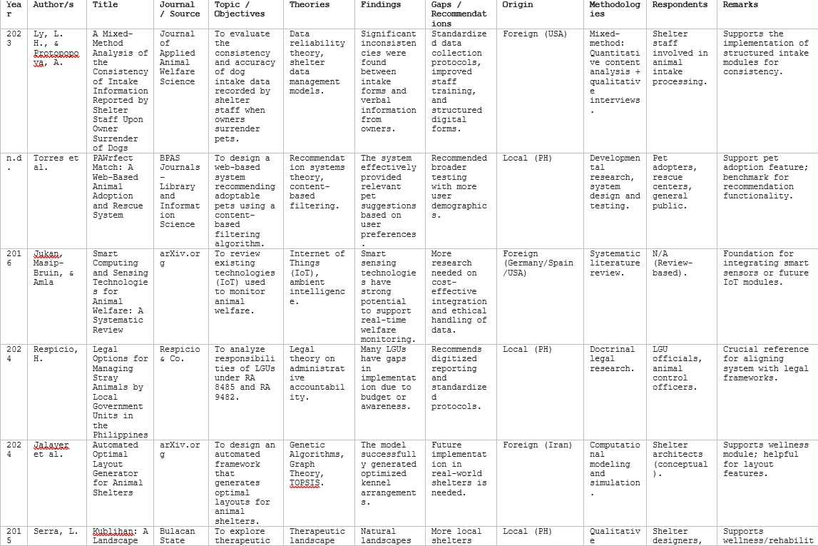
Matrix of the Literature
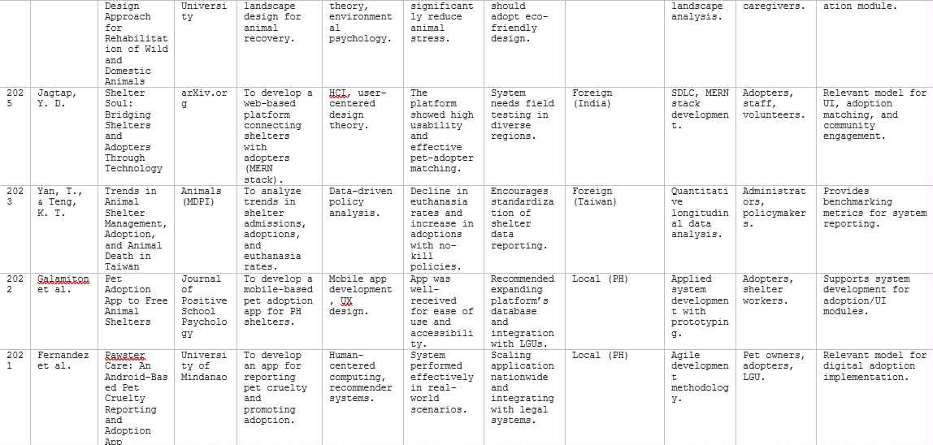

Table 3: Matrix of the Literature

CHAPTER III

Methodology

Development Methodology
For the development of the Catarman Dog Pound and Animal Shelter Management System (CDP&ASMS), we followed the Waterfall methodology because it provided a clear, step-by-step structure that worked well for our team. We started by gathering all the requirements and planning out the system in detail before moving on to the design, development, and testing phases. Each stage was completed before the next one began, which helped us stay organized and focused on one task at a time. This method worked well for us since our project had well-defined goals and didn't require constant changes. It also made it easier to document everything properly and ensure each part of the system was thoroughly reviewed before moving forward.

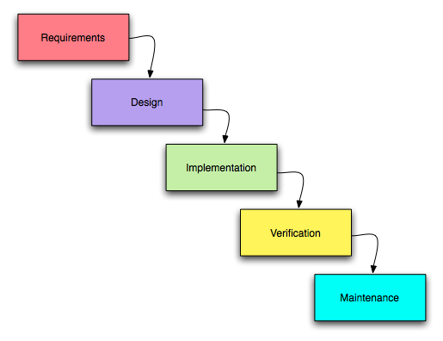Figure 1. Water Fall Methodology Diagram
Requirements Gathering
This phase involves understanding what the system needs to do. We meet with stakeholders to collect all the necessary information and list down the features and functions the system must have. Everything is clearly documented before moving forward.
System Design
After knowing the requirements, we design how the system will work. This includes layout planning, database and overall structure. The goal is to create a clear blueprint that guides the development phase.
Implementation (Coding)
In this phase, developers start building the actual system based on the design. They write the code for each feature, making sure it aligns with the requirements and design documents.
Testing
Once the system is built, it’s tested to check for bugs, errors, or issues. We make sure everything works as expected and fix any problems before the system goes live.
Deployment
After successful testing, the system is deployed or launched for users. This might involve setting it up on servers, giving access to users, and making the system ready for real-world use.
Maintenance
Even after deployment, the system needs regular updates, bug fixes, and adjustments. This phase ensures the system continues to run smoothly and meets users’ needs over time.

Requirements Specifications

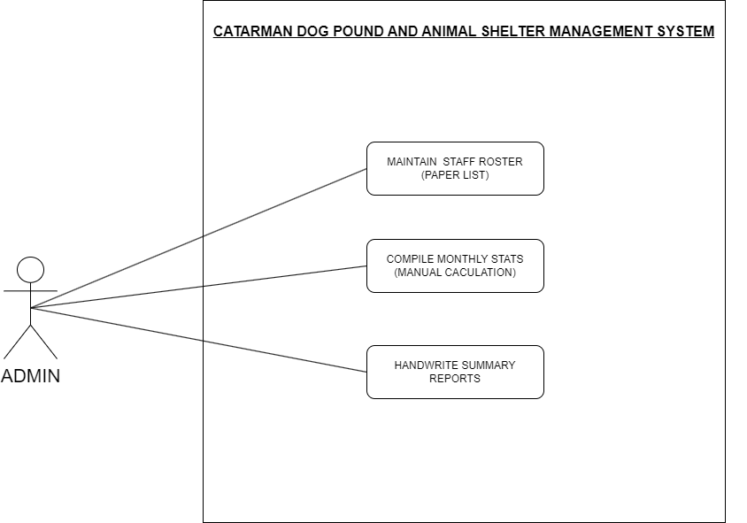
Use Case Diagram

Figure 2: Use Case of Admin 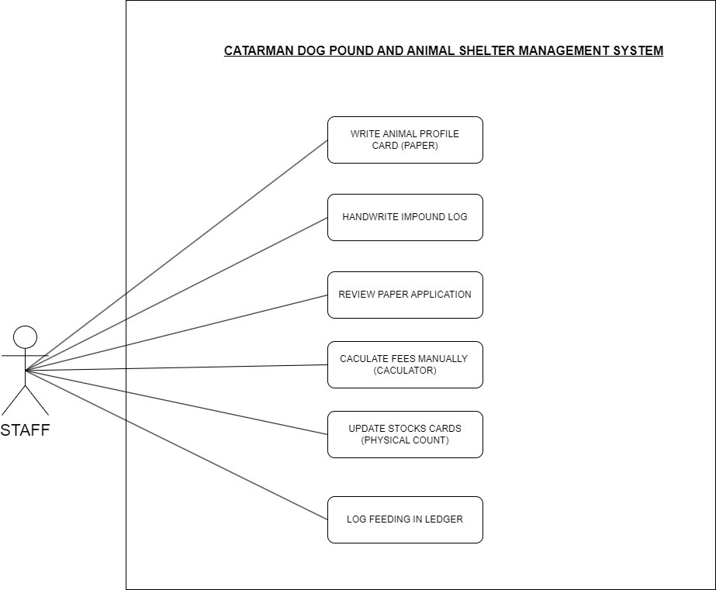

Figure 3: Use Case of Staff
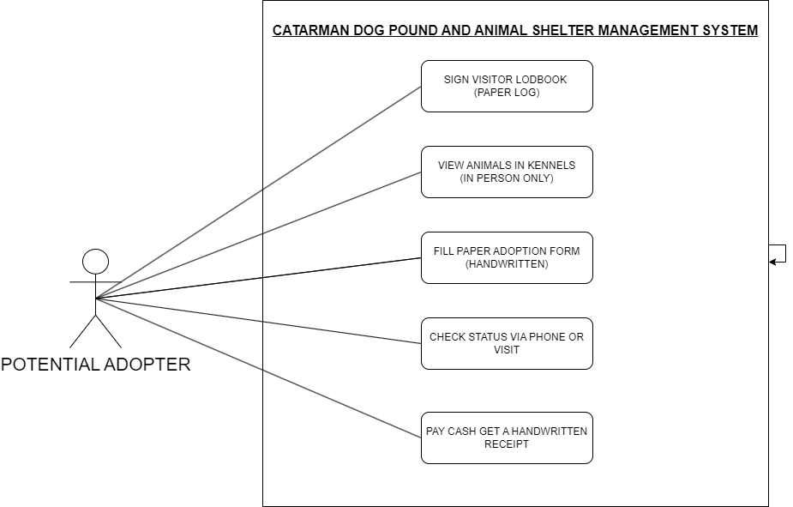

Figure 4: Use Case of Adopter
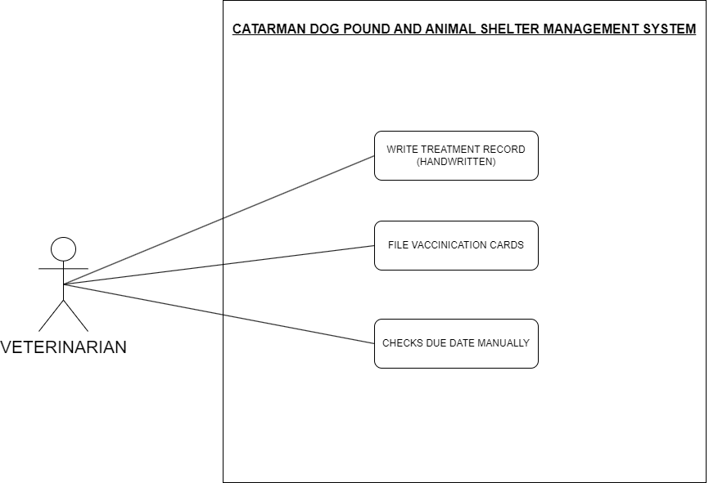

Figure 5: Use Case of Veterinarian

Compatibility Checking
Checking for compatibility to make sure the system complies with the hardware and software requirements for system development.

COMPONENT | MINIMUM REQUIREMENTS | RECOMMENDED  SPECIFICATIONS
PROCESSOR | Intel Core i5-114000H | Intel Core i5-114000H
RAM | 8GB | 16GB
STORAGE | 256GB | 512GB
OPERATING SYSTEM | Windows 11 Home | Windows 11 Home
DISPLAY RESOLUTION | 1920 x 1080 | 1920 x 1080

Table 4: System Development Hardware Specification
The recommended hardware specifications are listed to ensure best performance of the system by using the given recommendation specs.

Table 5: System Development Software Specification
SOFTWARE COMPONENT | REQUIRED VERSION | COMPATIBLE PLATFORMS
OPERATING SYSTEM | Windows 11 | Windows
DATABASE MANAGEMENT SYSTEM | MySQL 8.0 or higher | Cross-platform
PROGRAMMING LANGUAGES | HTML5, CSS3, JavaScript, and PHP | Windows
WEB BROWSER | Google Chrome (Latest) | Cross-platform
APPLICATION SERVER | XAMPP 8.2.0 or higher | Windows
INTEGRATED DEVELOPMENT ENVIRONMENT | Visual Studio Code (Latest) | Cross-platform
Contains a list of minimum and recommended software it requires in developing the system.

Relevance of the Technologies
This section explains the rationale for selecting the specific hardware, software, and technologies used in the development of the Catarman Dog Pound & Animal Shelter Management System. Each component was chosen based on its features, compatibility, and ability to support the system’s operational and functional goals.
HTML, CSS, and JavaScript
These technologies are foundational for web development.
HTML5 defines the structure and content of web pages.
CSS3 handles the design, layout, and responsiveness of the user interface, ensuring it works across a variety of screen sizes and devices.
JavaScript (ES6+) enables dynamic and interactive content, such as form validations and responsive UI updates.
Their broad compatibility, large support community, and ease of deployment make them highly suitable for building the front end of a public-facing web-based management system.
PHP
A PHP Backend refers to the server-side infrastructure of a web application developed using PHP (Hypertext Preprocessor). It acts as the "brain" of the application, responsible for managing data, executing application logic, and communicating with databases before sending processed information back to the user's interface (the frontend).
Unlike the frontend, which runs in the user's browser, the PHP backend executes entirely on the web server. It handles critical tasks such as user authentication, file processing, and database queries (Create, Read, Update, Delete).
MySQL
MySQL is used as the central database system for our system. It stores and manages all structured data that the system processes, such as animal information, medical histories, adoption applications, appointments, user accounts, donation records, and lost or found reports. MySQL allows the system to keep data organized, consistent, and easy to retrieve or update.
LAN and HTTP/HTTPS
The system can operate in both a Local Area Network (LAN) and cloud-based deployment.
A LAN setup ensures local accessibility for shelter staff, while HTTPS enables secure remote access if cloud-hosted.
HTTPS is especially critical for securing sensitive information like adopter personal data, login credentials, and donation details.

Requirements Modeling
This section describes how the system requirements are modeled. It details the inputs, processes, outputs, performance expectations, and controls of the Catarman Dog Pound & Animal Shelter Management System.

Input
a. User Information: Staff, veterinarians, and adopters will input personal details including name, email, role, and login credentials.
b. Animal Records: Staff and veterinarians will enter animal details such as breed, age, condition, intake date and current status.
c. Health Records: Veterinarians will log vaccination history, treatments, health issues, and medical interventions for each animal.
d. Adoption Requests: Potential adopters can submit requests including their contact info, chosen animal, and personal background.
e. Inventory Data: Staff will input supply details such as stock quantity, item type, supplier info, and restocking dates.
f. Audit Entries: The system records staff and veterinarian activities for accountability (e.g., animal edits, user actions).
g. Report Filters: Staff can input filters like date range, animal type, or adoption status to generate specific reports.

Process
a. Staff and veterinarians log in using their system credentials.
b. Staff input and update animal profiles, including intake and adoption status.
c. Veterinarians enter and manage animal health records such as vaccinations, treatments, and medical notes.
d. Staff manage inventory records including updates on supplies, restocking, and low stock alerts.
e. Potential adopters browse available animals and submit adoption requests.
f. Staff review, approve, or deny adoption requests based on adopter info and animal status.
g. Approved adopters receive notification via email.
h. Staff and veterinarians use the dashboard to track shelter operations and monitor animal status.
i. Staff generate reports related to adoption trends, animal health summaries, and shelter inventory.

Output
a. Reports: System generates reports on animal health records, adoption statistics, inventory usage, and user activity logs.
b. Animal Availability Listings: Up-to-date animal profiles viewable by staff and potential adopters.
c. Notifications: Email confirmations or alerts for adoption status, system access, or report availability.
d. Audit Logs: System records user activity for accountability and traceability.

Performance
a. Responsiveness: The system should load pages and process user actions within 5 to 10 seconds under normal operating conditions.
b. Scalability: Capable of handling increased data such as animal records, user accounts, and inventory growth without performance issues.
c. Availability: The system should be operational 24/7, with minimal downtime for maintenance or updates.
d. Data Integrity: All submitted and stored information should be consistent, complete, and accurate across the system.

Control
a. User Management: Admins have the ability to create, edit, or deactivate user accounts including staff, vets, and adopters.
b. Access Control: System functions are limited based on user roles—for example, only veterinarians can update medical records.
c. Data Validation: Input fields are checked for completeness and accuracy (e.g., no blank required fields, correct date format).
d. Session Monitoring: Inactive users are automatically logged out after a set period to maintain security.
e. Error Handling: System displays clear error messages (e.g., input errors, failed logins) and logs them for review.

Security
a. Authentication: Users are required to log in using a unique username and password. Strong password policies and optional multi-factor authentication should be enforced.
b. Access Control: System restricts sensitive features such as report generation, animal data management, and user administration to authorized roles only.
c. Data Encryption: All sensitive information is encrypted at rest and in transit to protect data integrity and user privacy.
d. Audit Trail: The system records all critical user actions for accountability, including logins, record edits, and report generation.

Process, Interface and Data Modeling

Process Modeling
Process modeling is the categorization and documenting of how data and structure are being processed by a system as it is meant to be used.

Context Diagram

Current System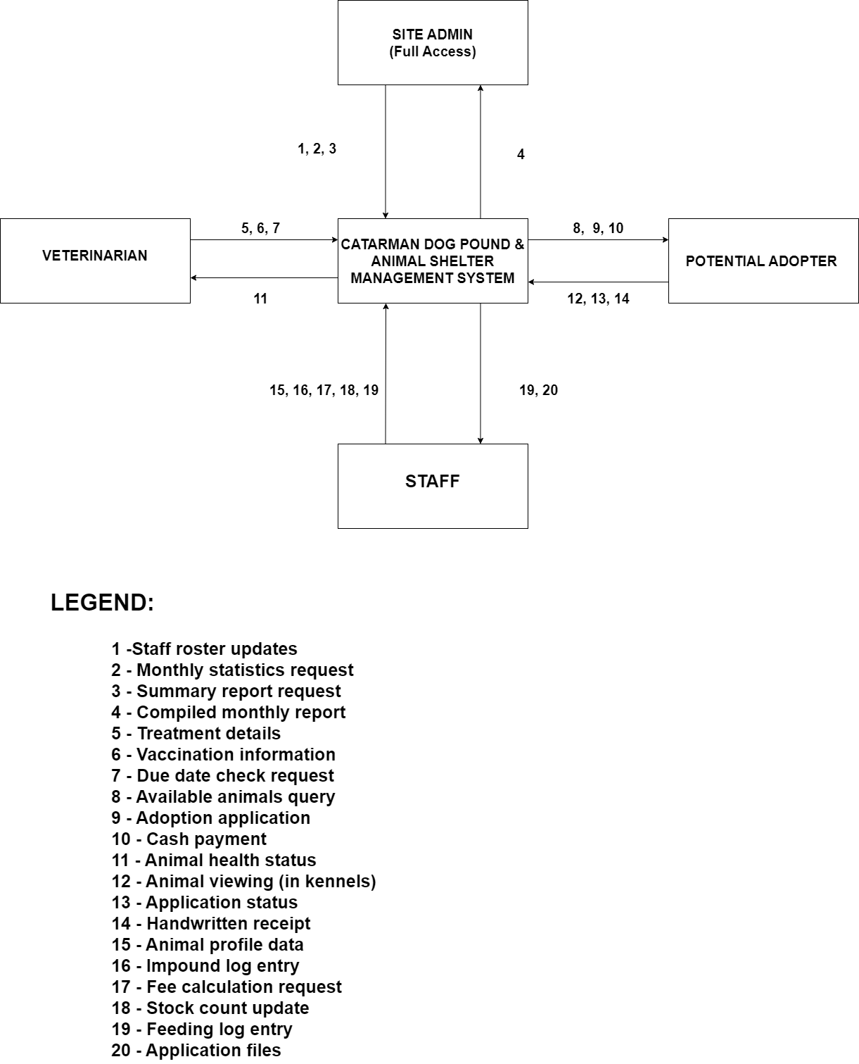

Figure 6: Context Diagram for Current System

The context diagram shows how the current system at the Catarman Dog Pound & Animal Shelter operates through manual interactions between staff, veterinarians, and dog enforcers. Each group shares and receives information such as animal admissions, medical records, and adoption details without the aid of an automated system. This manual process often leads to delays, inconsistencies, and difficulty in tracking important data, which highlights the need for a digital solution to streamline operations and improve coordination among users.

Proposed System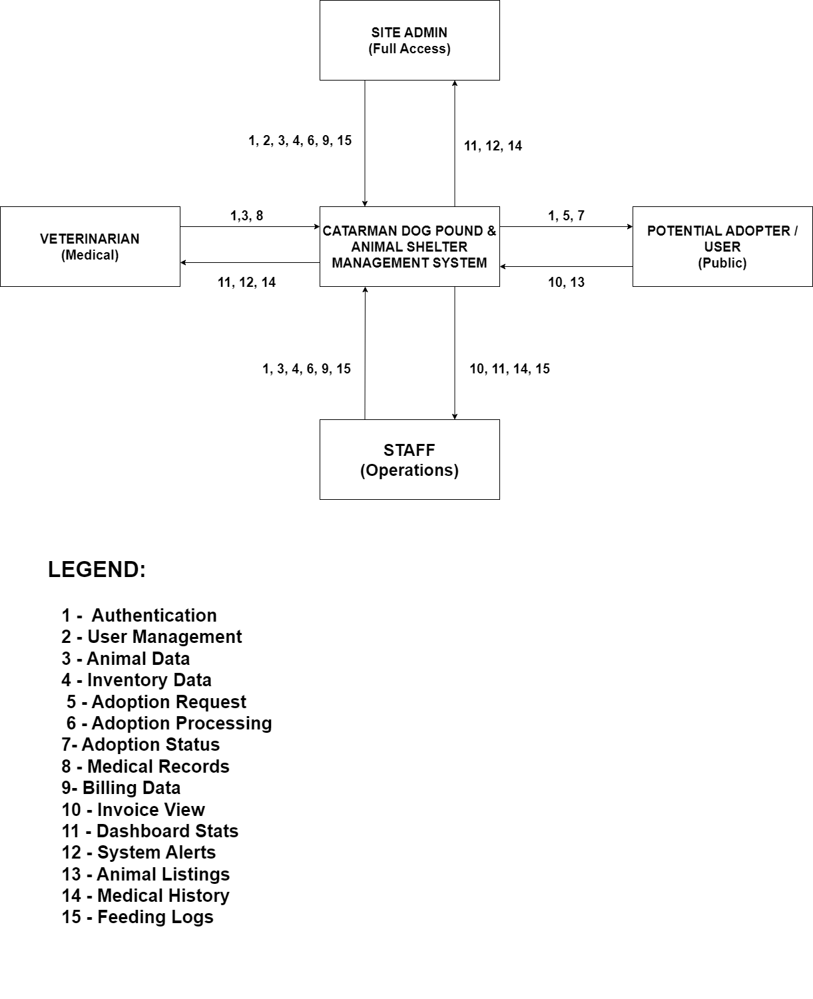

Figure 7: Context Diagram for Proposed System
It illustrates a conceptual site structure for the "Catarman Dog Pound & Animal Shelter Management System" under consideration.It provides a description of the system's project scope and names the system’s users and managers.

Functional Decomposition Diagram
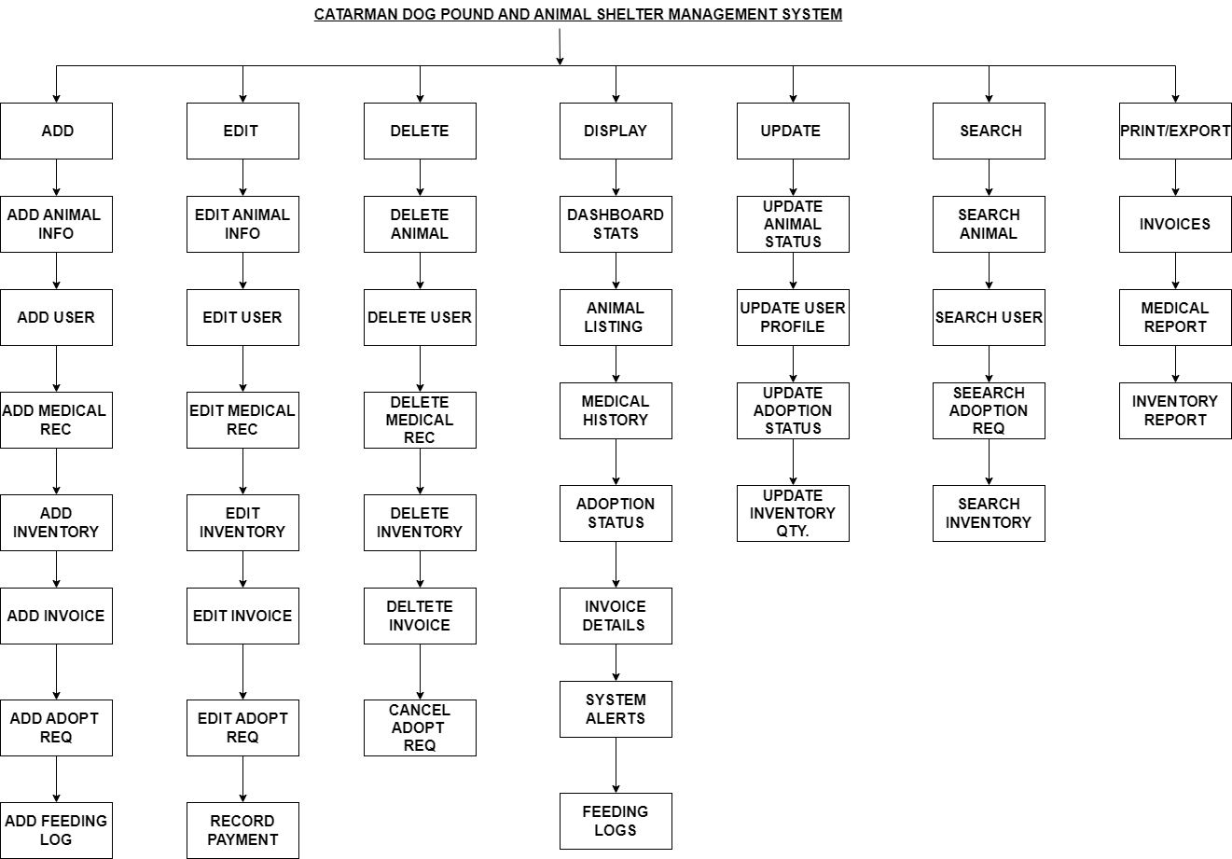

Figure 8: Functional Decomposition Diagram
The "Catarman Dog Pound & Animal Shelter Management System" is functionally decomposed into several core operations: Add, Update, Search, Mark for Deletion, View, Report, Print, and User Management. Each of these primary functions branches into specific sub-functions, such as managing animal information, user data, animal health records, inventory, and generating various reports. The system also includes functionalities for handling available animals for adoption, audit logs, a dashboard, and user registration, login, and logout processes.

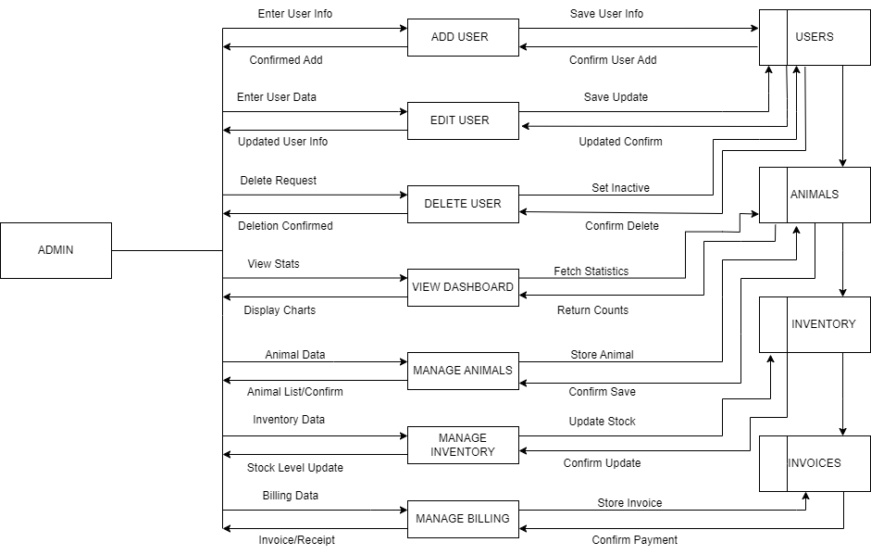
Event Diagrams

Figure 9: Admin Event Diagram
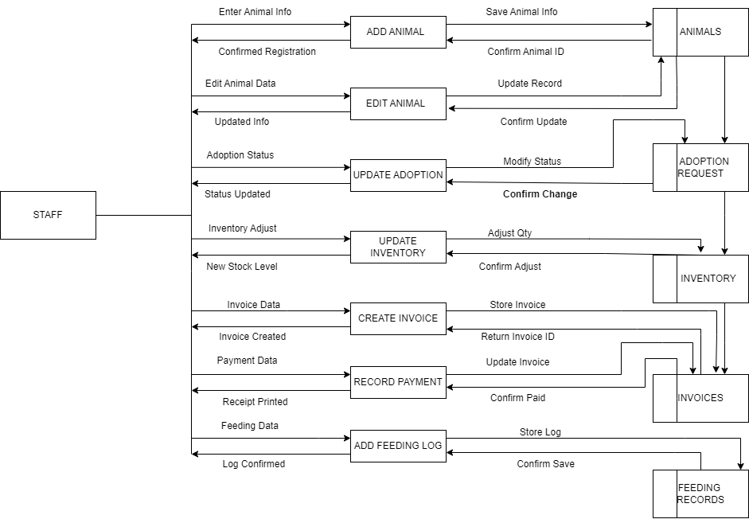

Figure 10: Staff Event Diagram

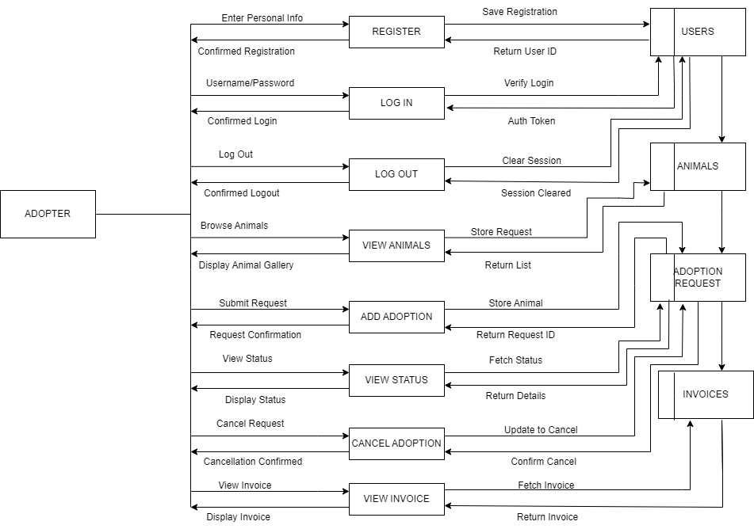

Figure 11: Adopter Event Diagram
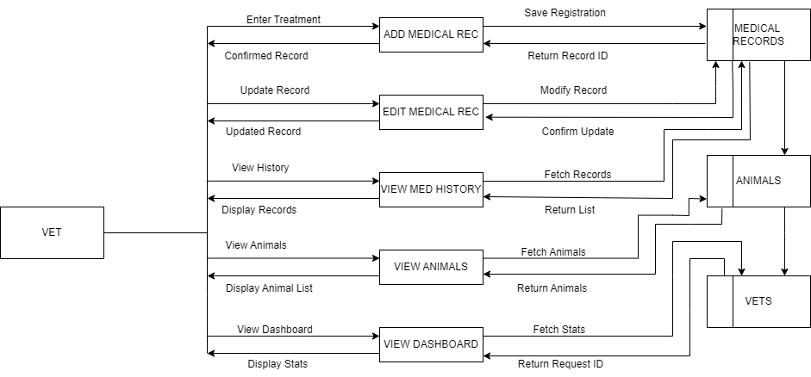

Figure 12: Veterinarian Event Diagram
This Diagram is constructed to give a clear view of each event involved in the system. It shows the inputs, outputs, and data store interactions for the event.

System Diagram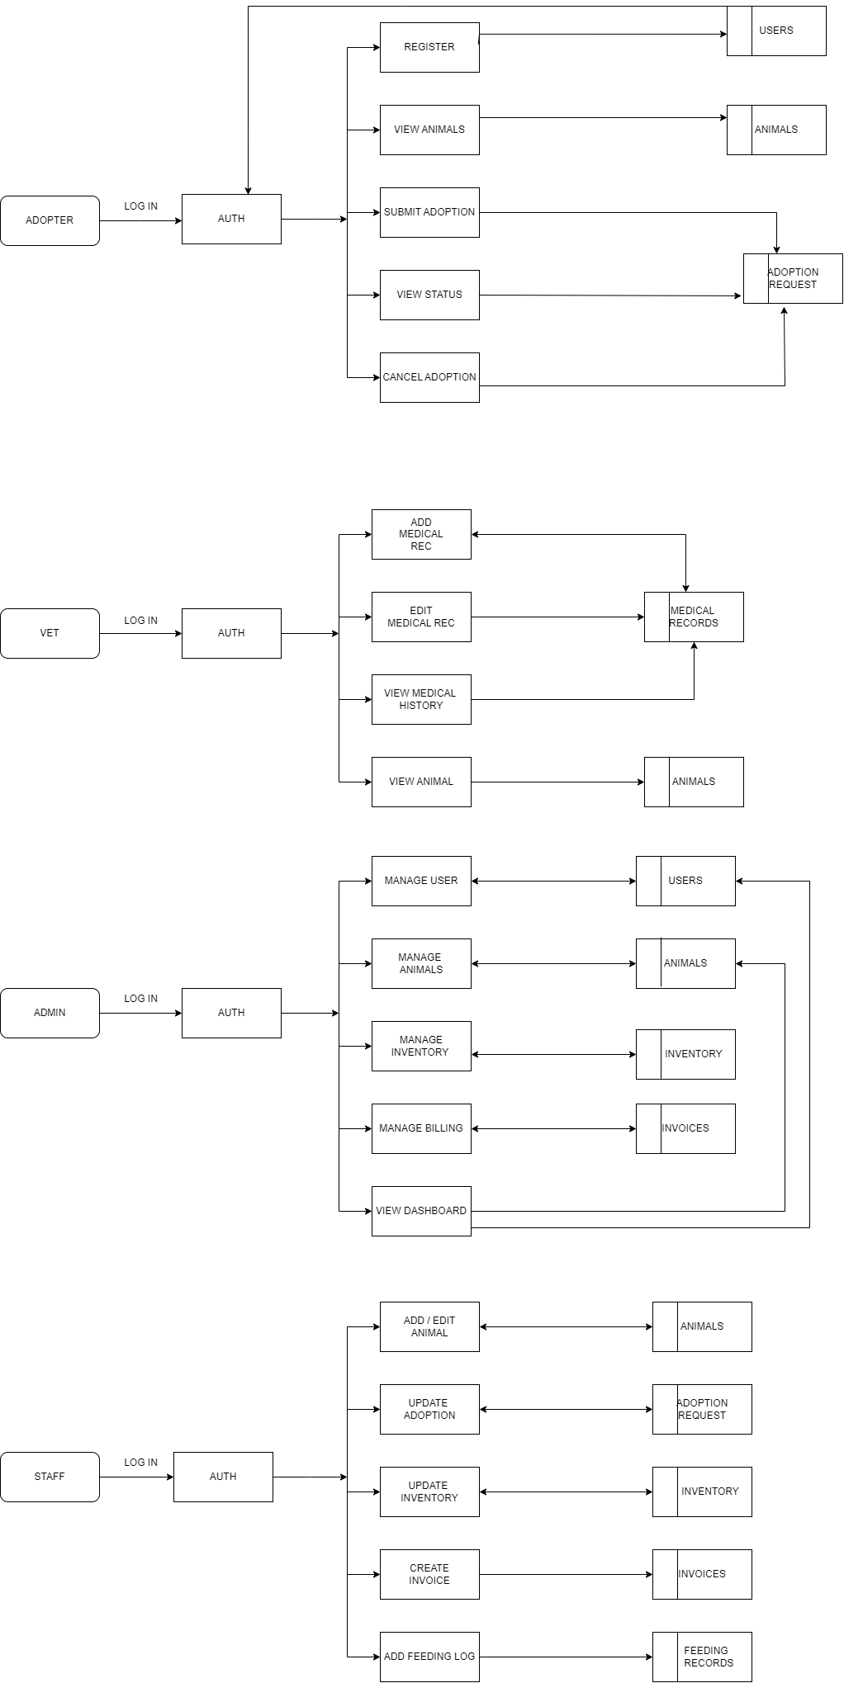

Figure 13: System Diagram

Interface Model
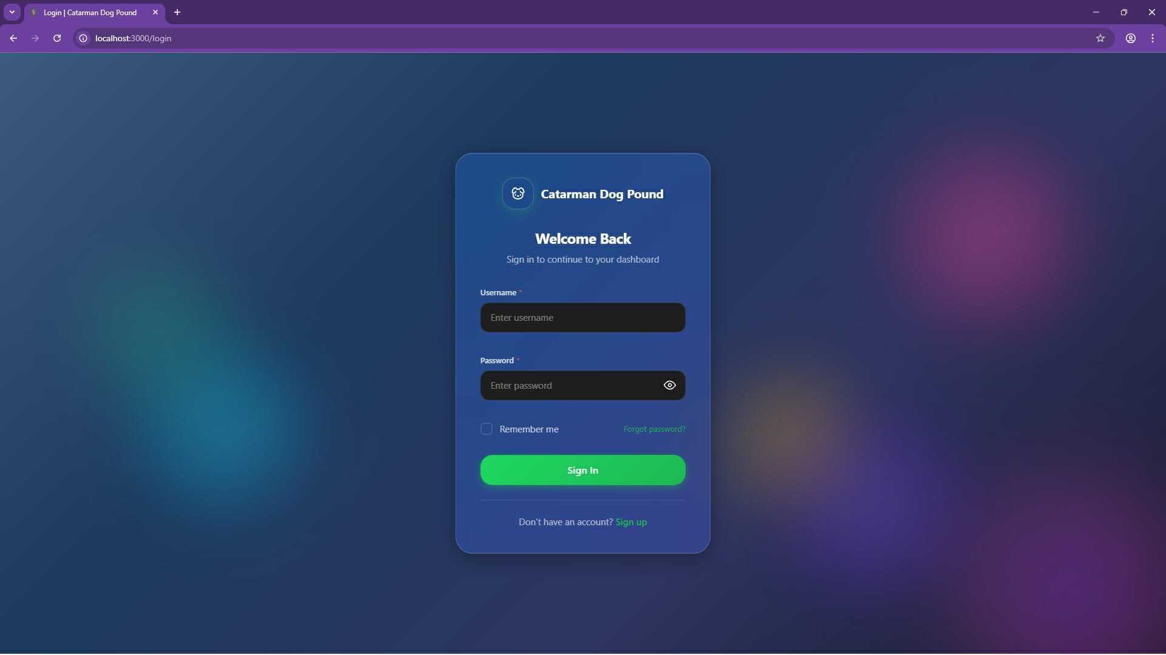

Figure 14: Log in Form
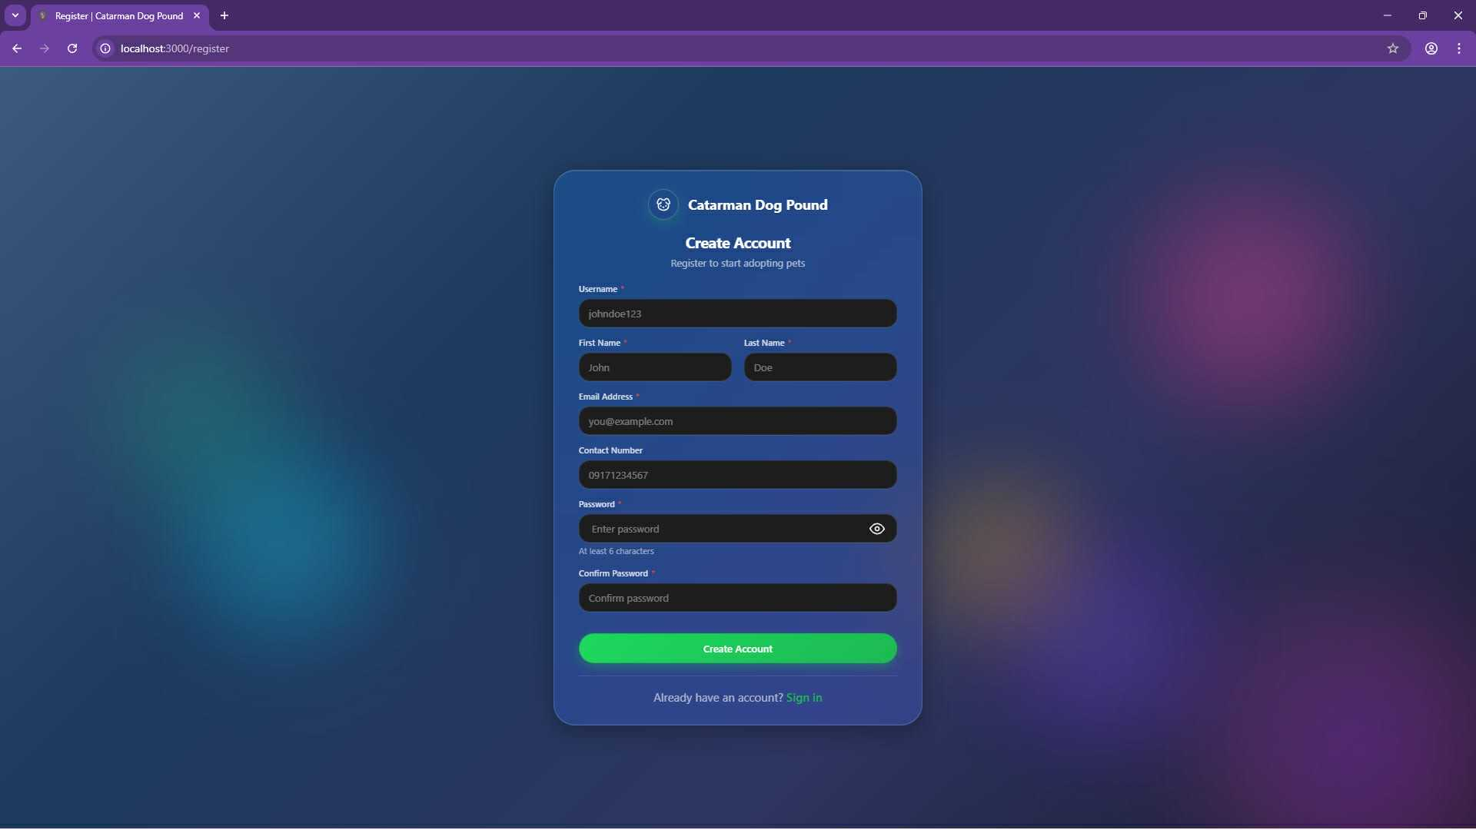

Figure 15: Sign up Form

Admin UI

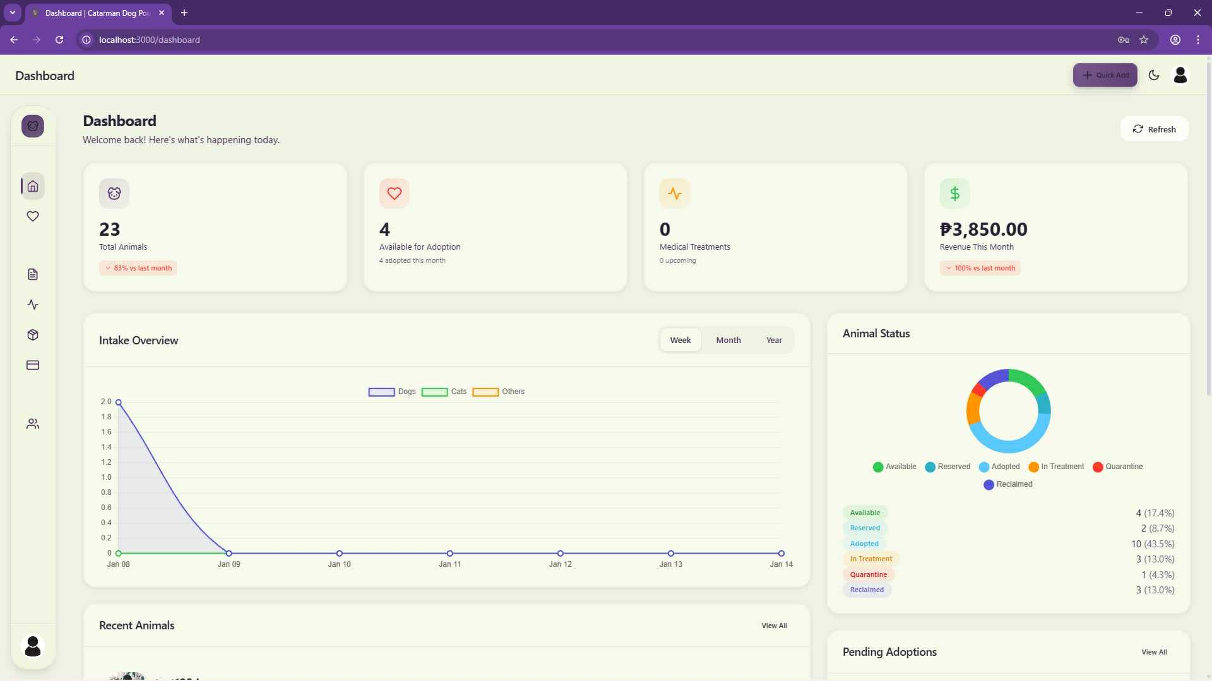Figure 16: Admin Main Dashboard Page

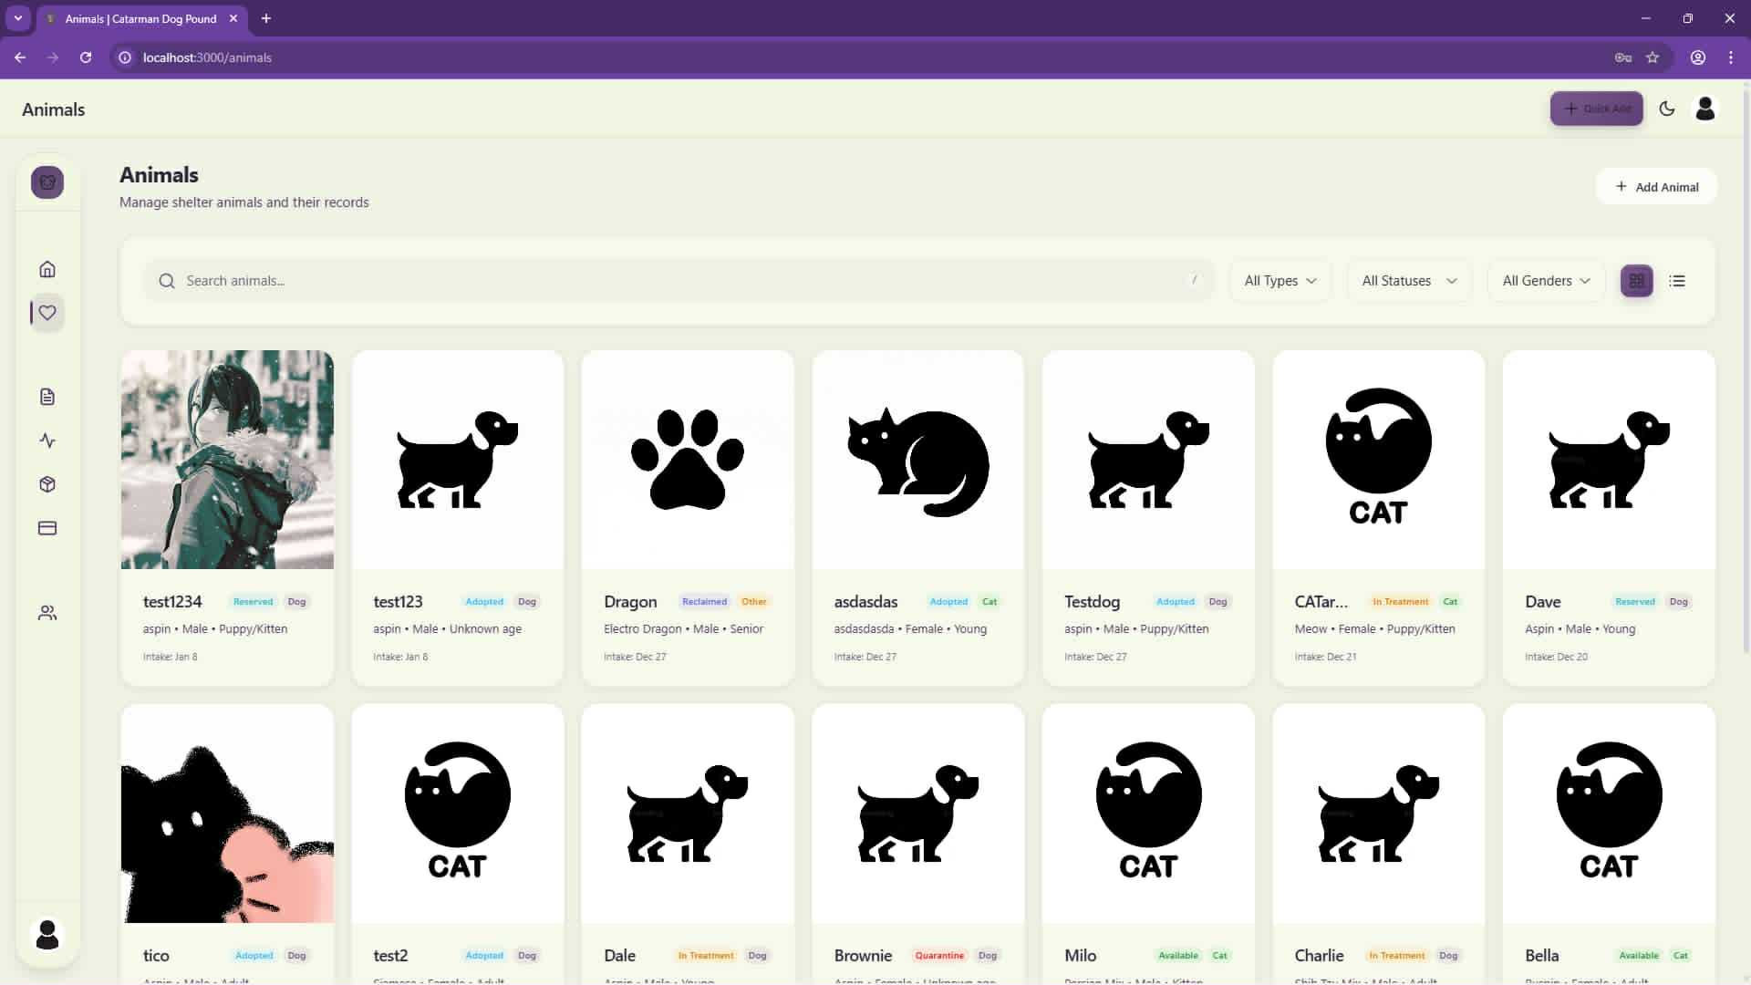

Figure 17: Admin Animal Page

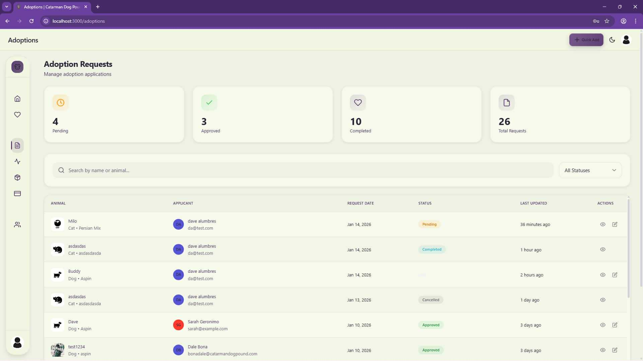

Figure 18: Admin Adoption Request Page

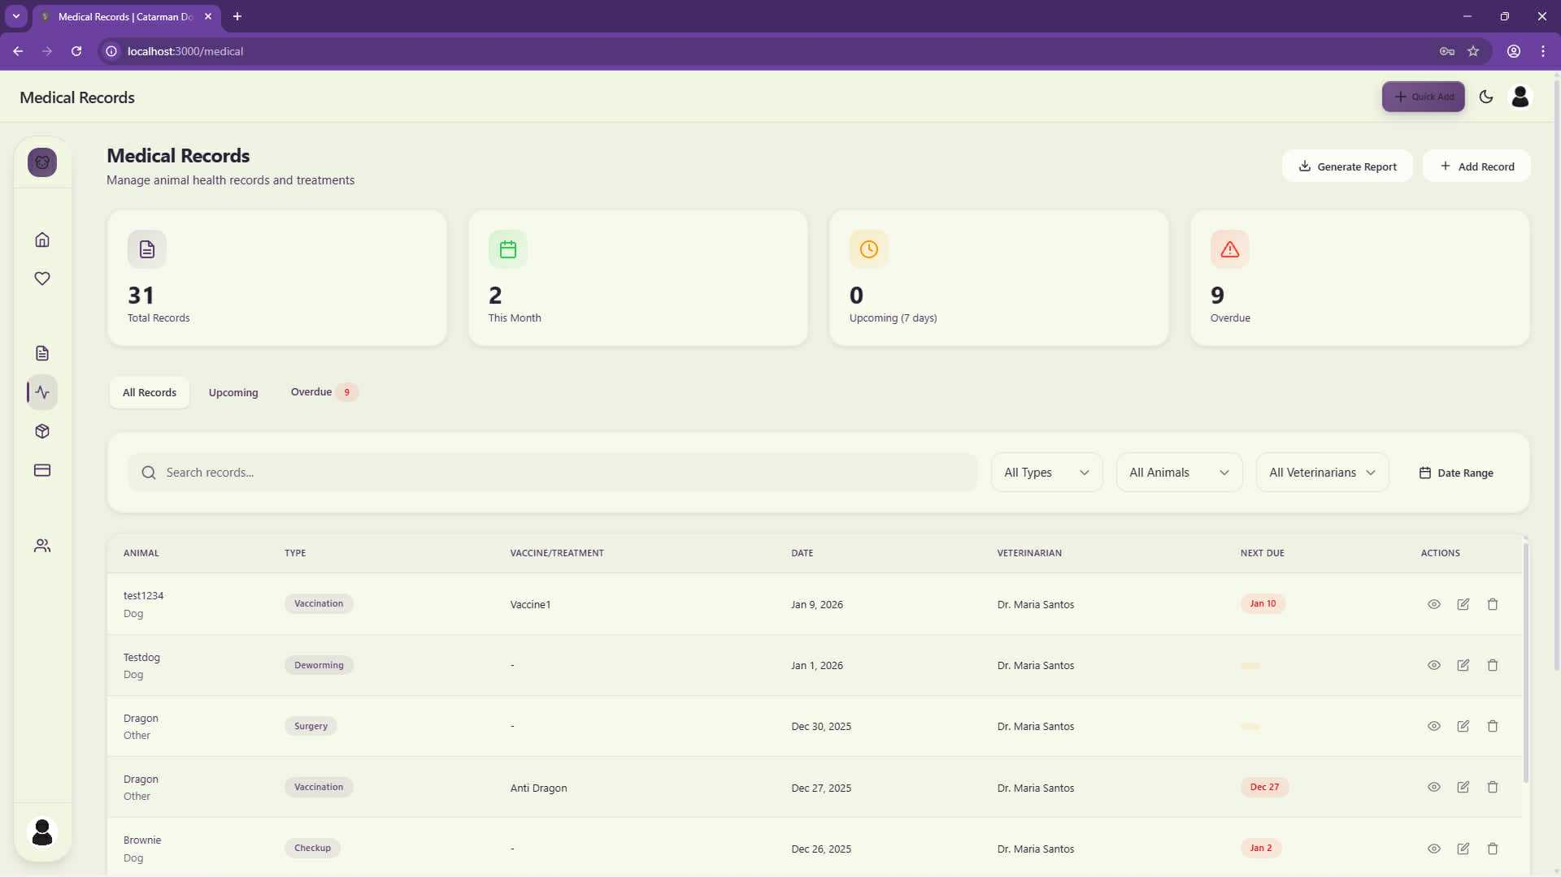

Figure 19: Admin Medical Record Page

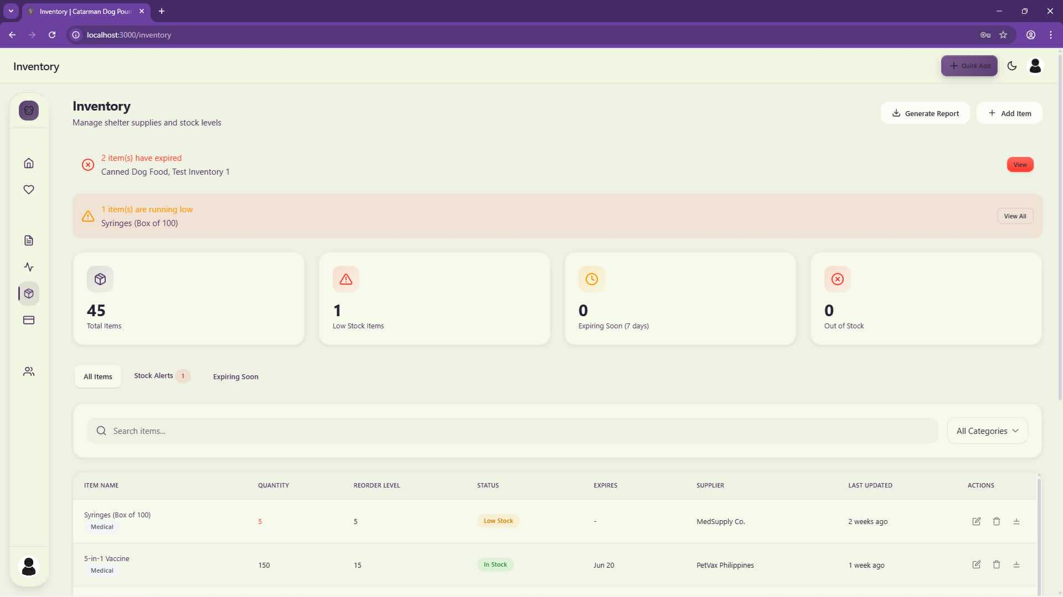

Figure 20: Admin Inventory Page
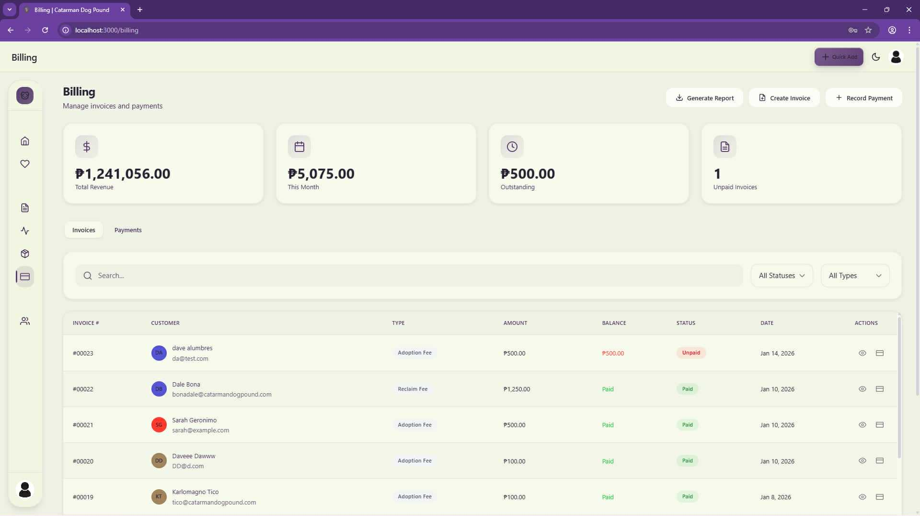

Figure 21: Admin Billing Page

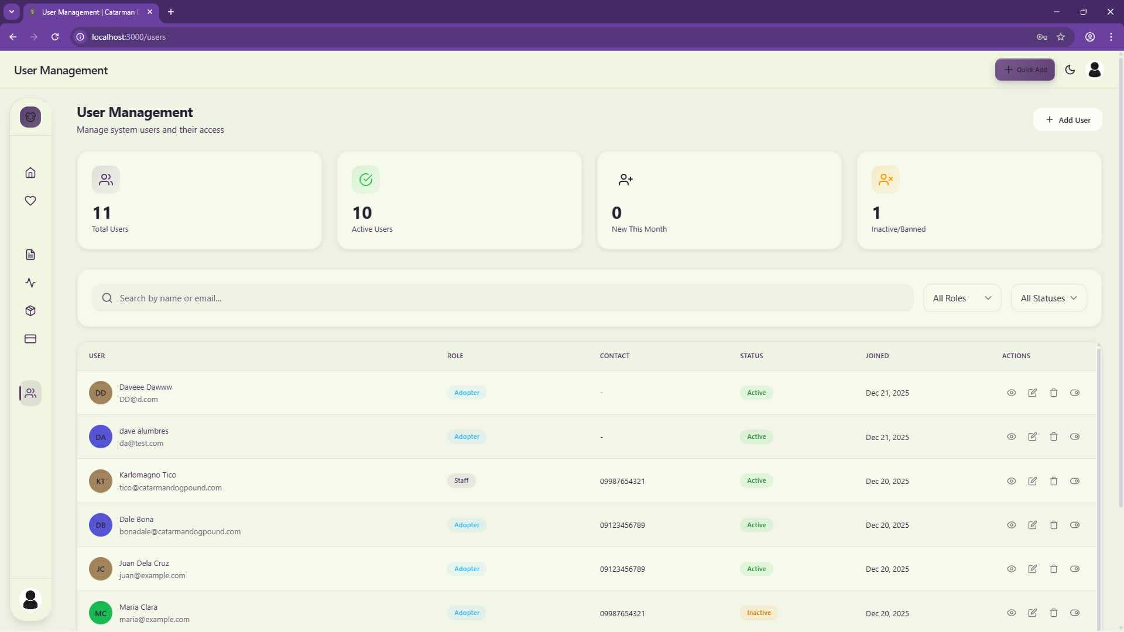

Figure 22: User Management Page
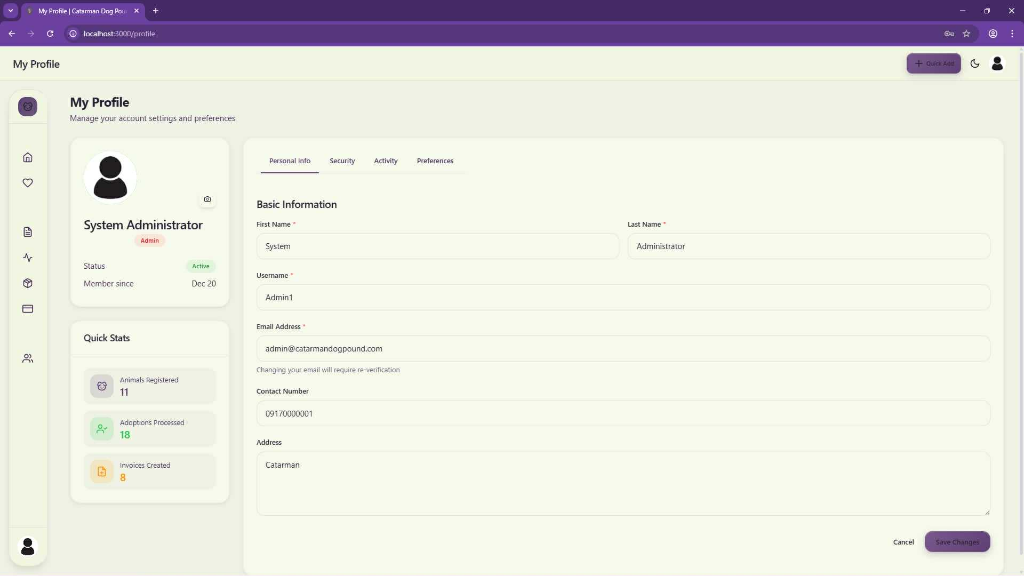

Figure 23: Admin Profile Page

Staff UI
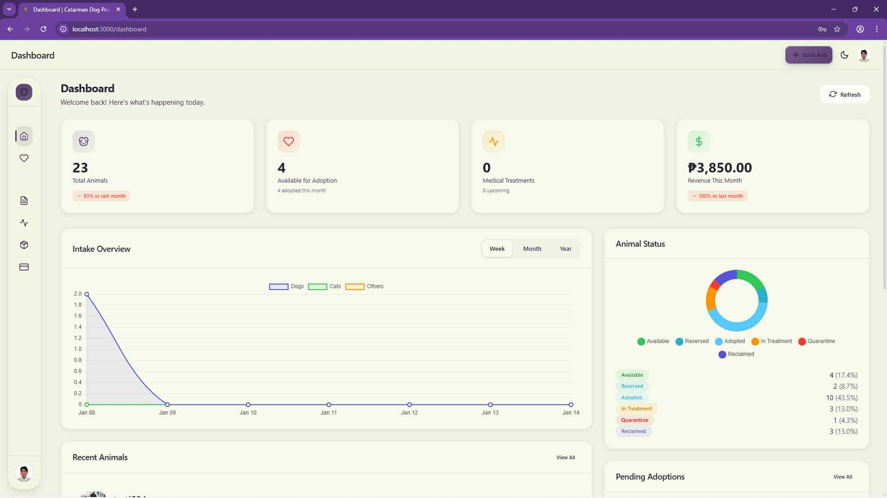

Figure 24: Staff Main Dashboard

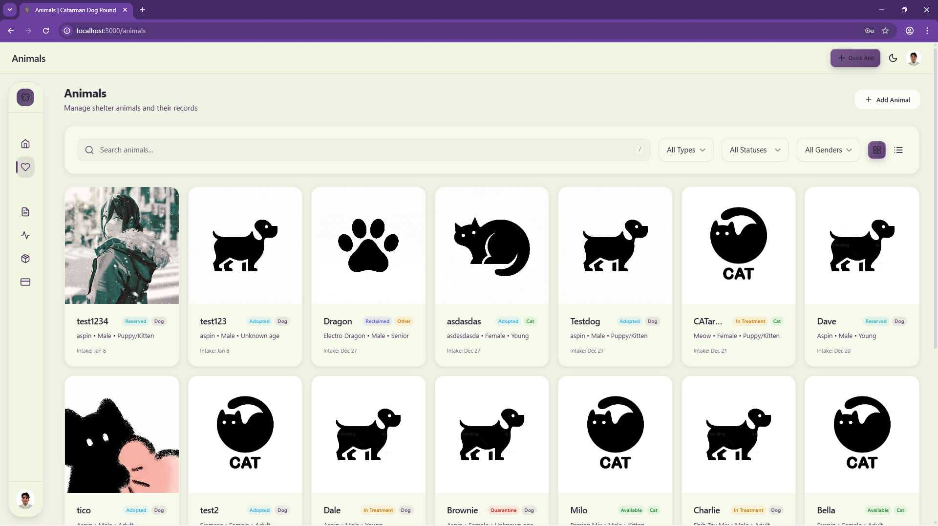Figure 25: Staff Animal Page

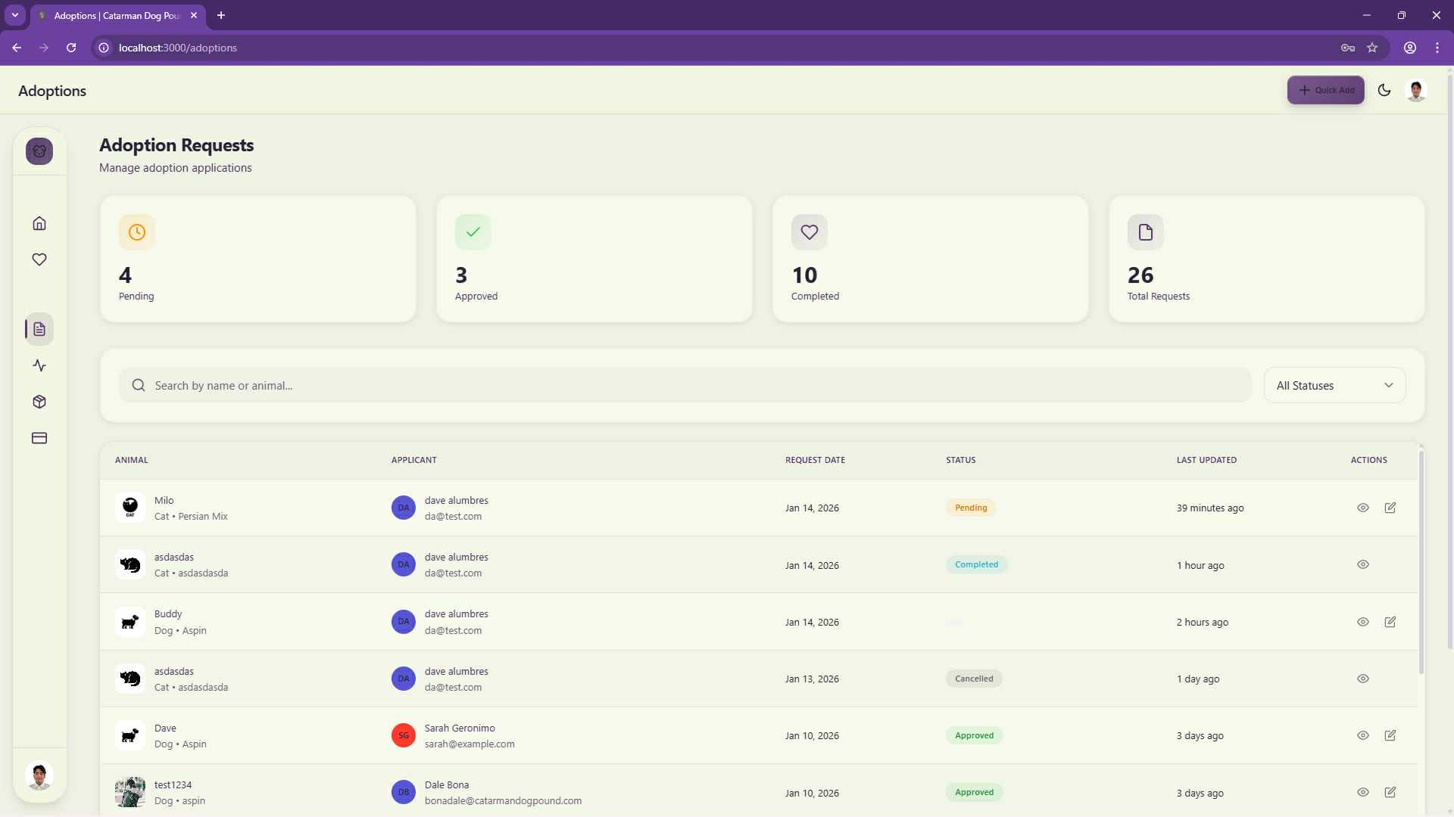

Figure 26: Staff Adoption Request Page

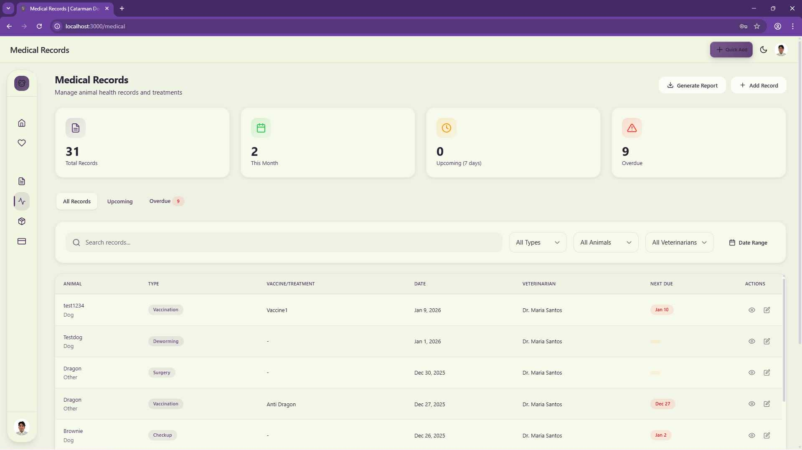

Figure 27: Staff Medical Records Page

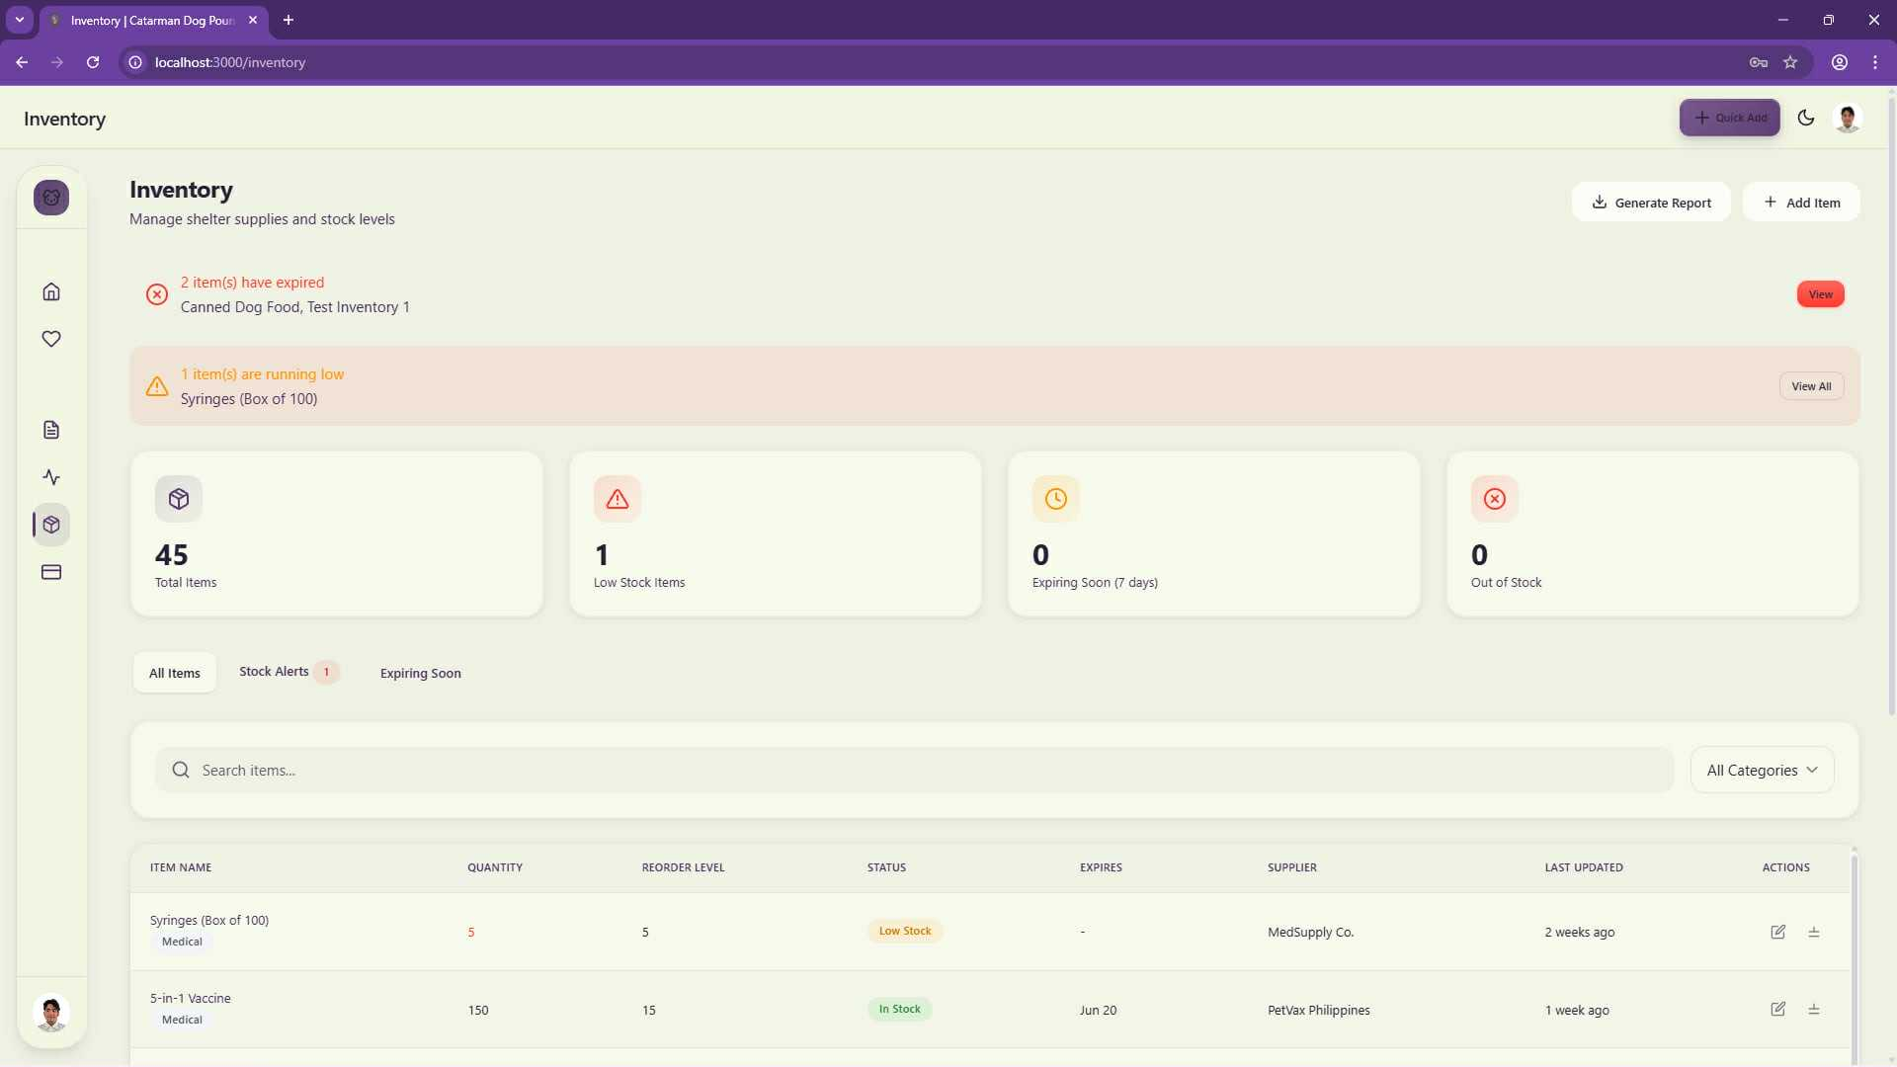

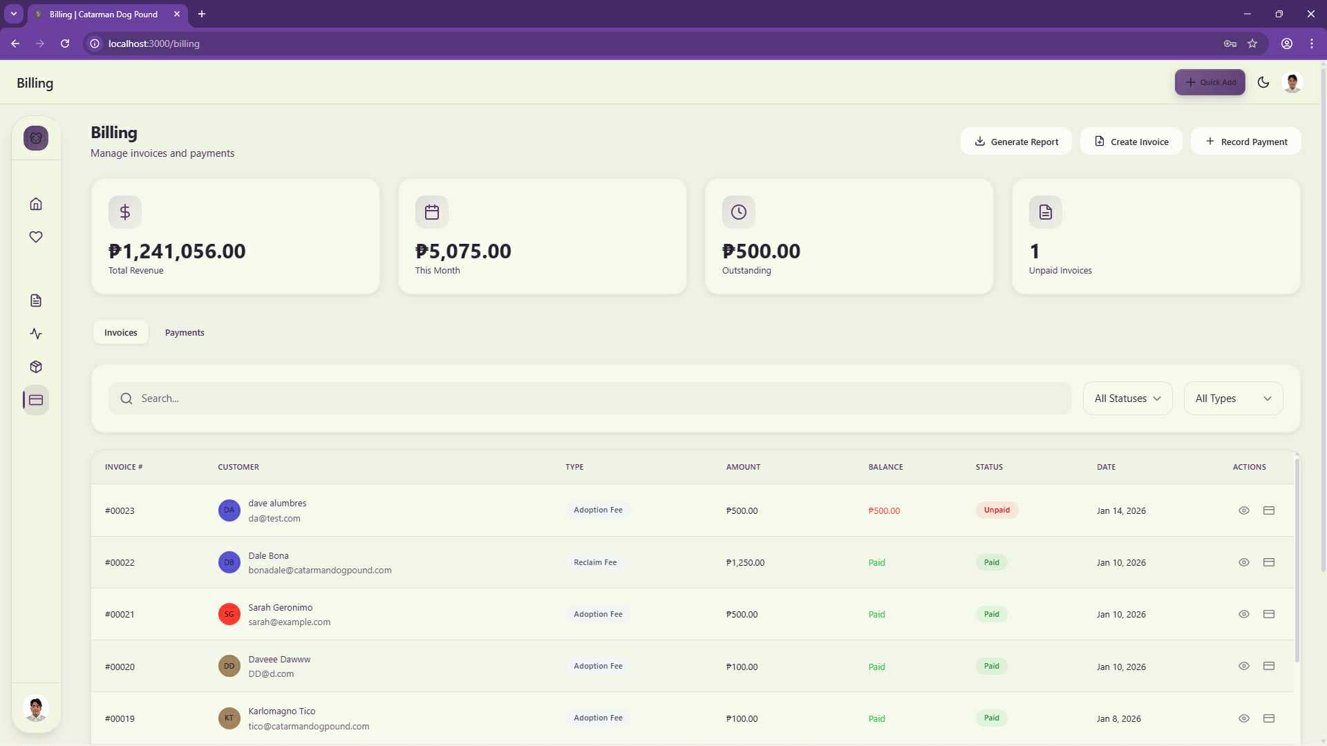
Figure 28: Staff Inventory Page

Figure 29: Staff Billing Page

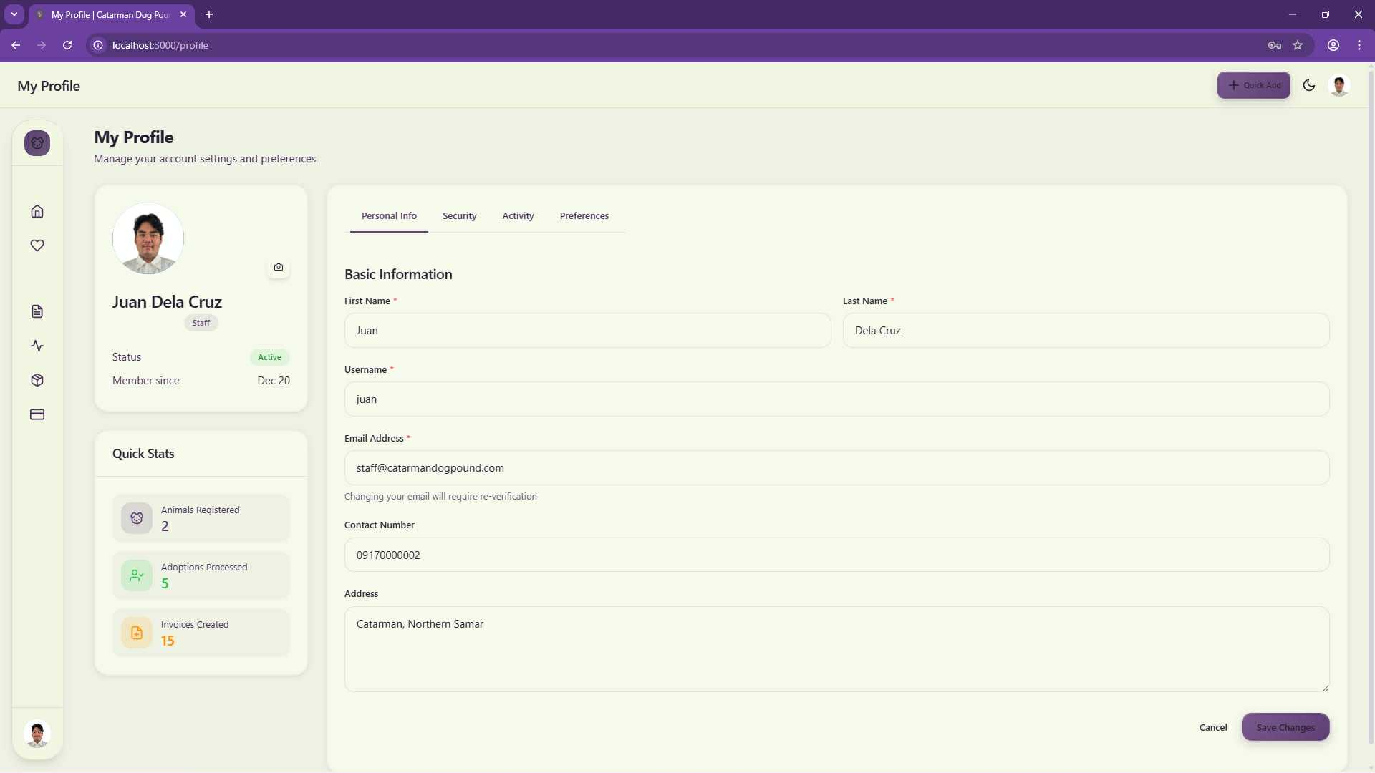

Figure 30: Staff Profile Page

Veterinarian UI
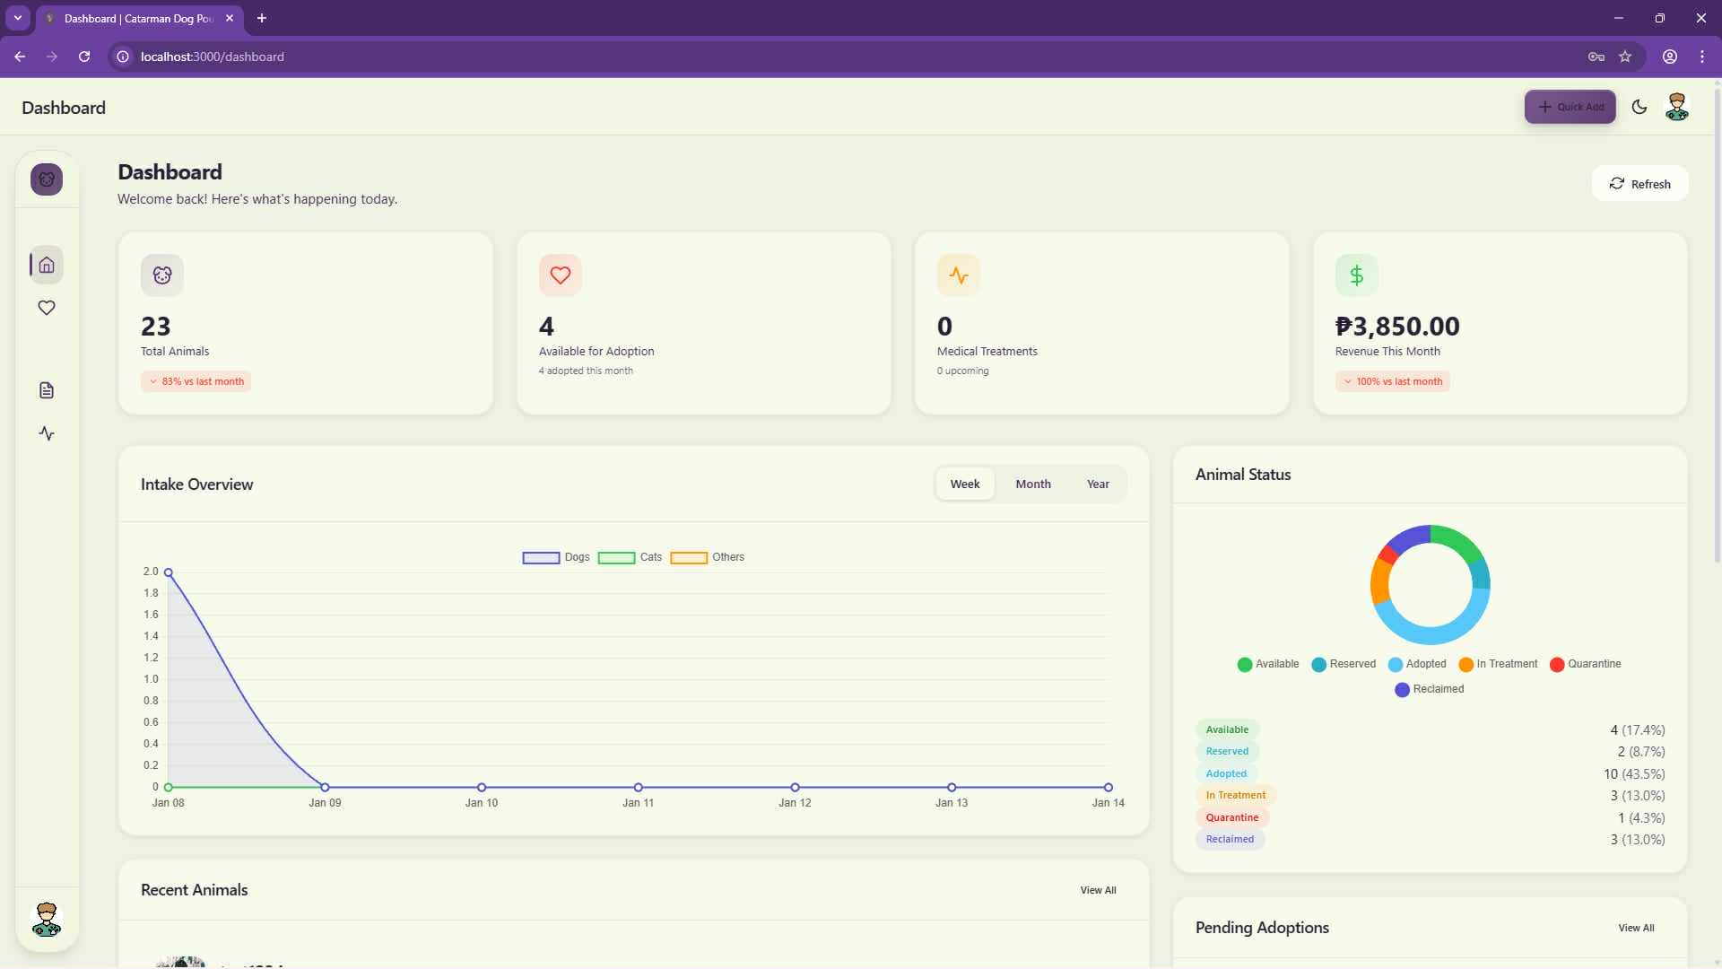

Figure 31: Veterinarian Main Dashboard

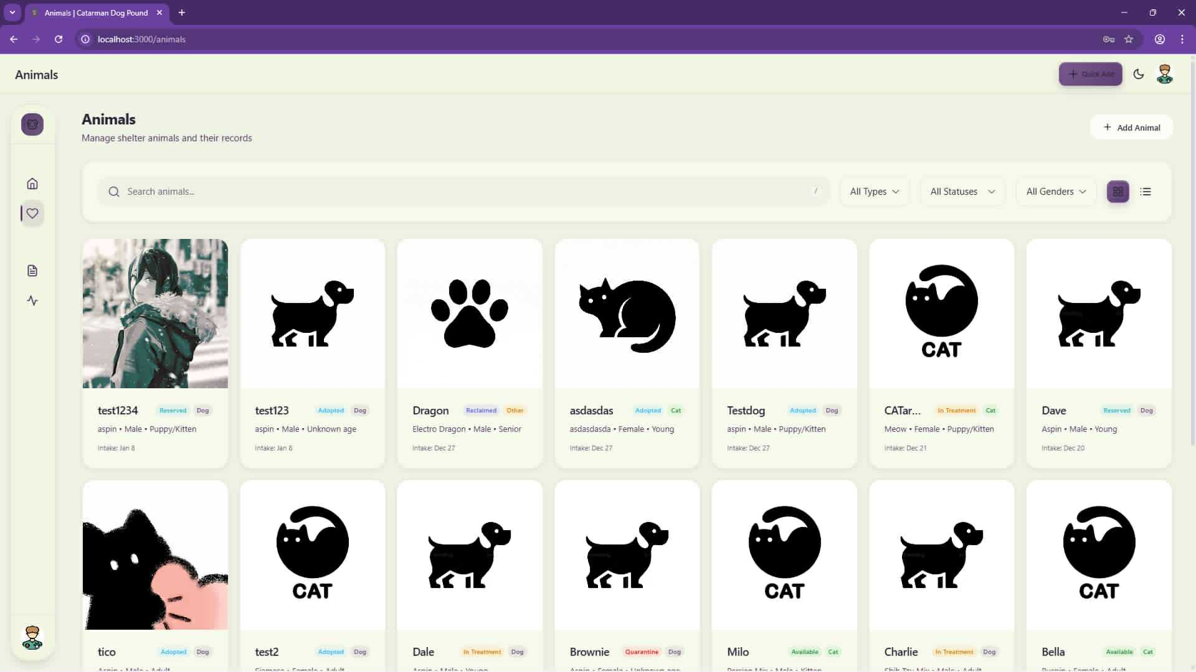Figure 32: Veterinarian Animal Page

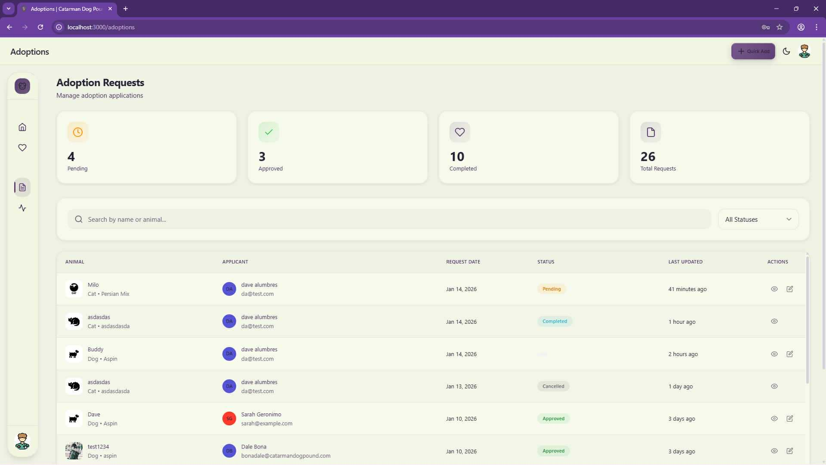Figure 33: Veterinarian Adoption Request Page

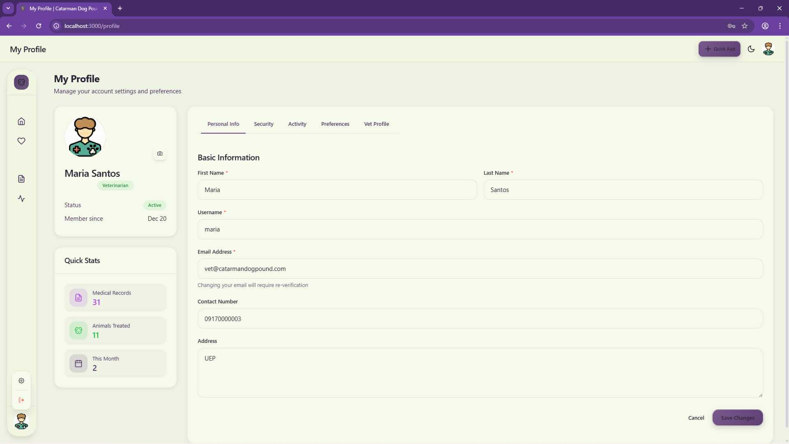
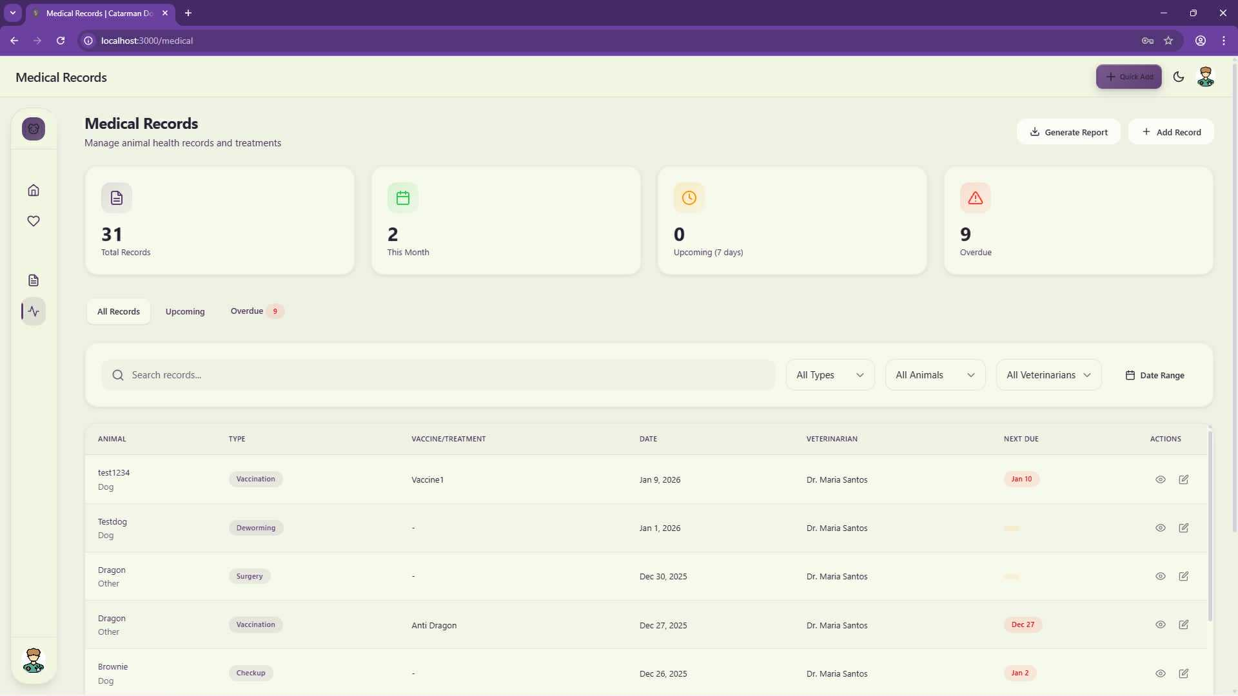Figure 34: Veterinarian Medical Records Page

Figure 35: Veterinarian Profile Page

Adopter UI

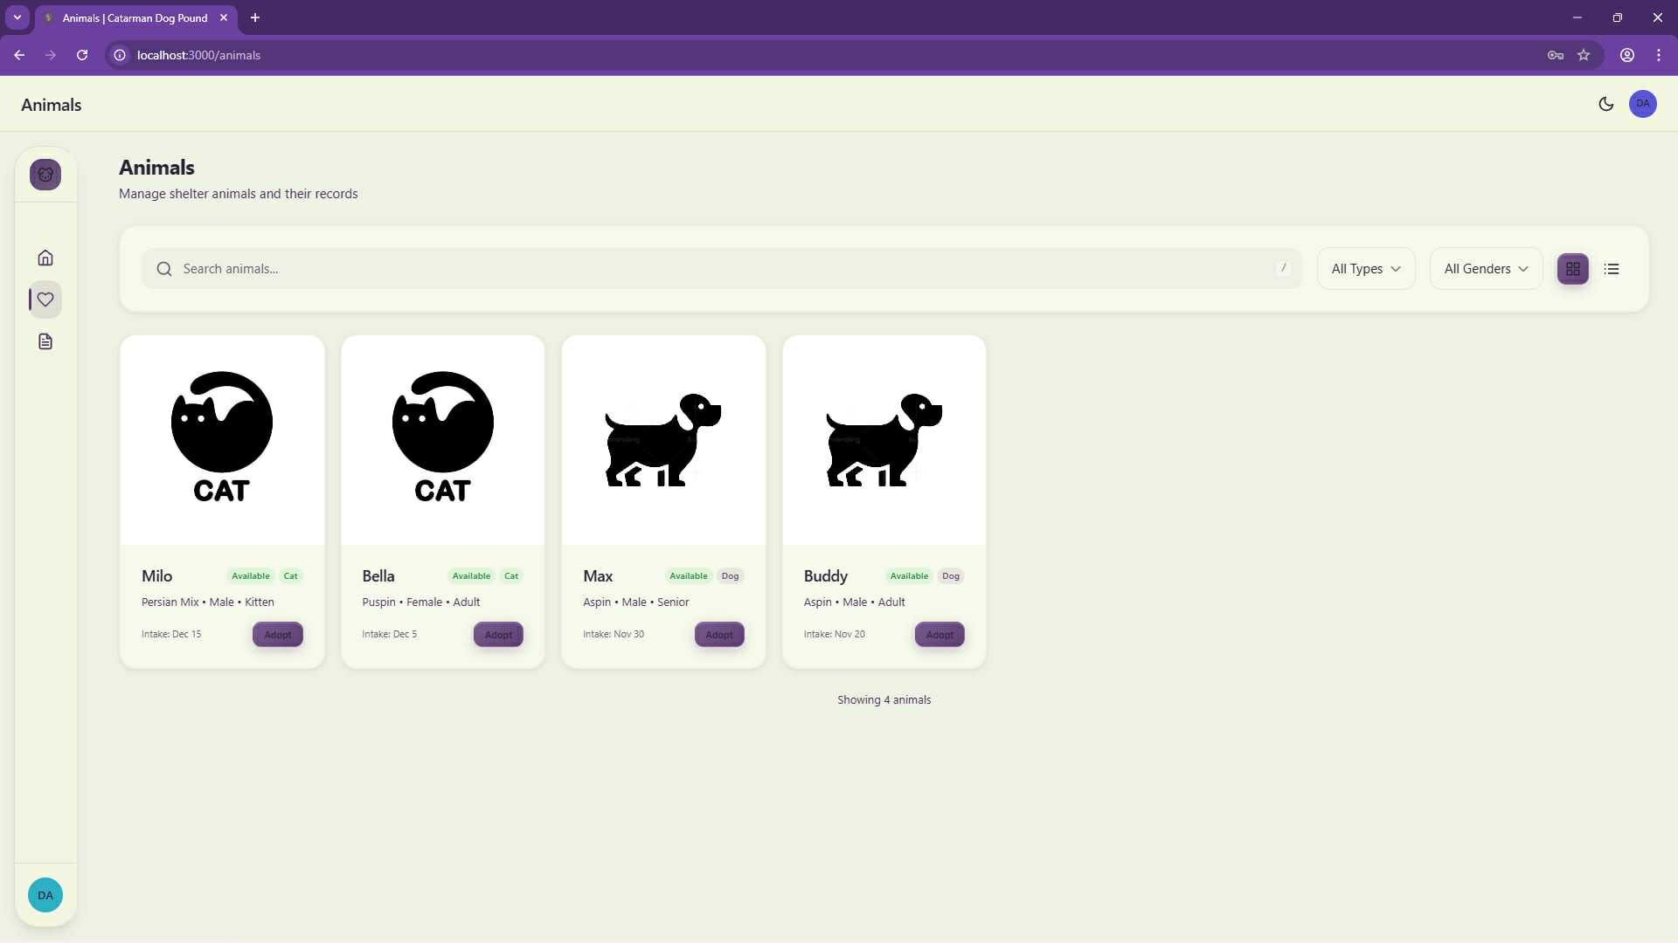
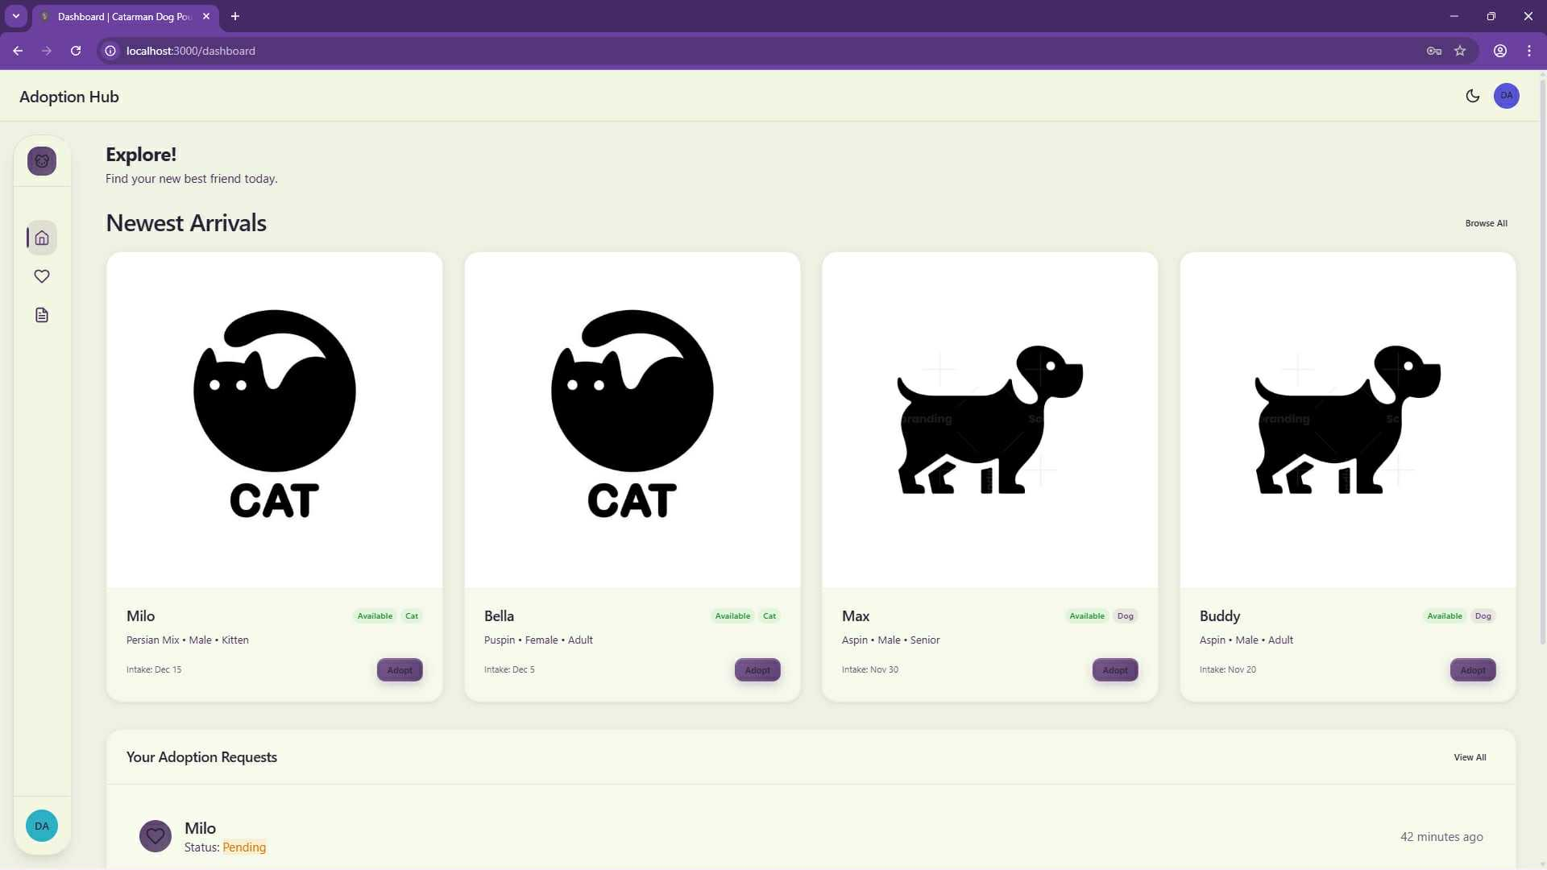
Figure 36: Adopter Explore Page


Figure 37: Adopter Animal View Page

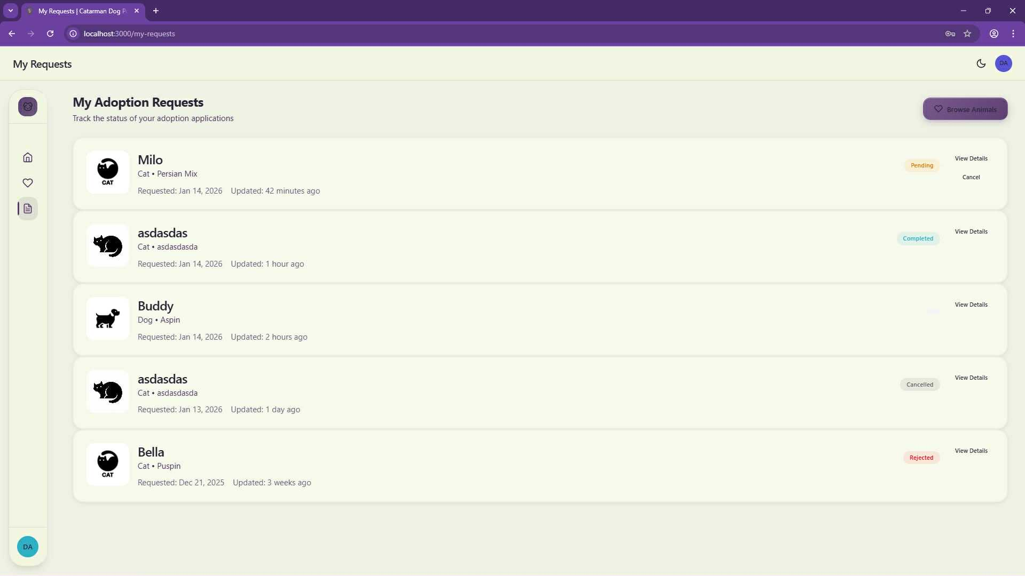

Figure 38: Adopter Adoption Request Page
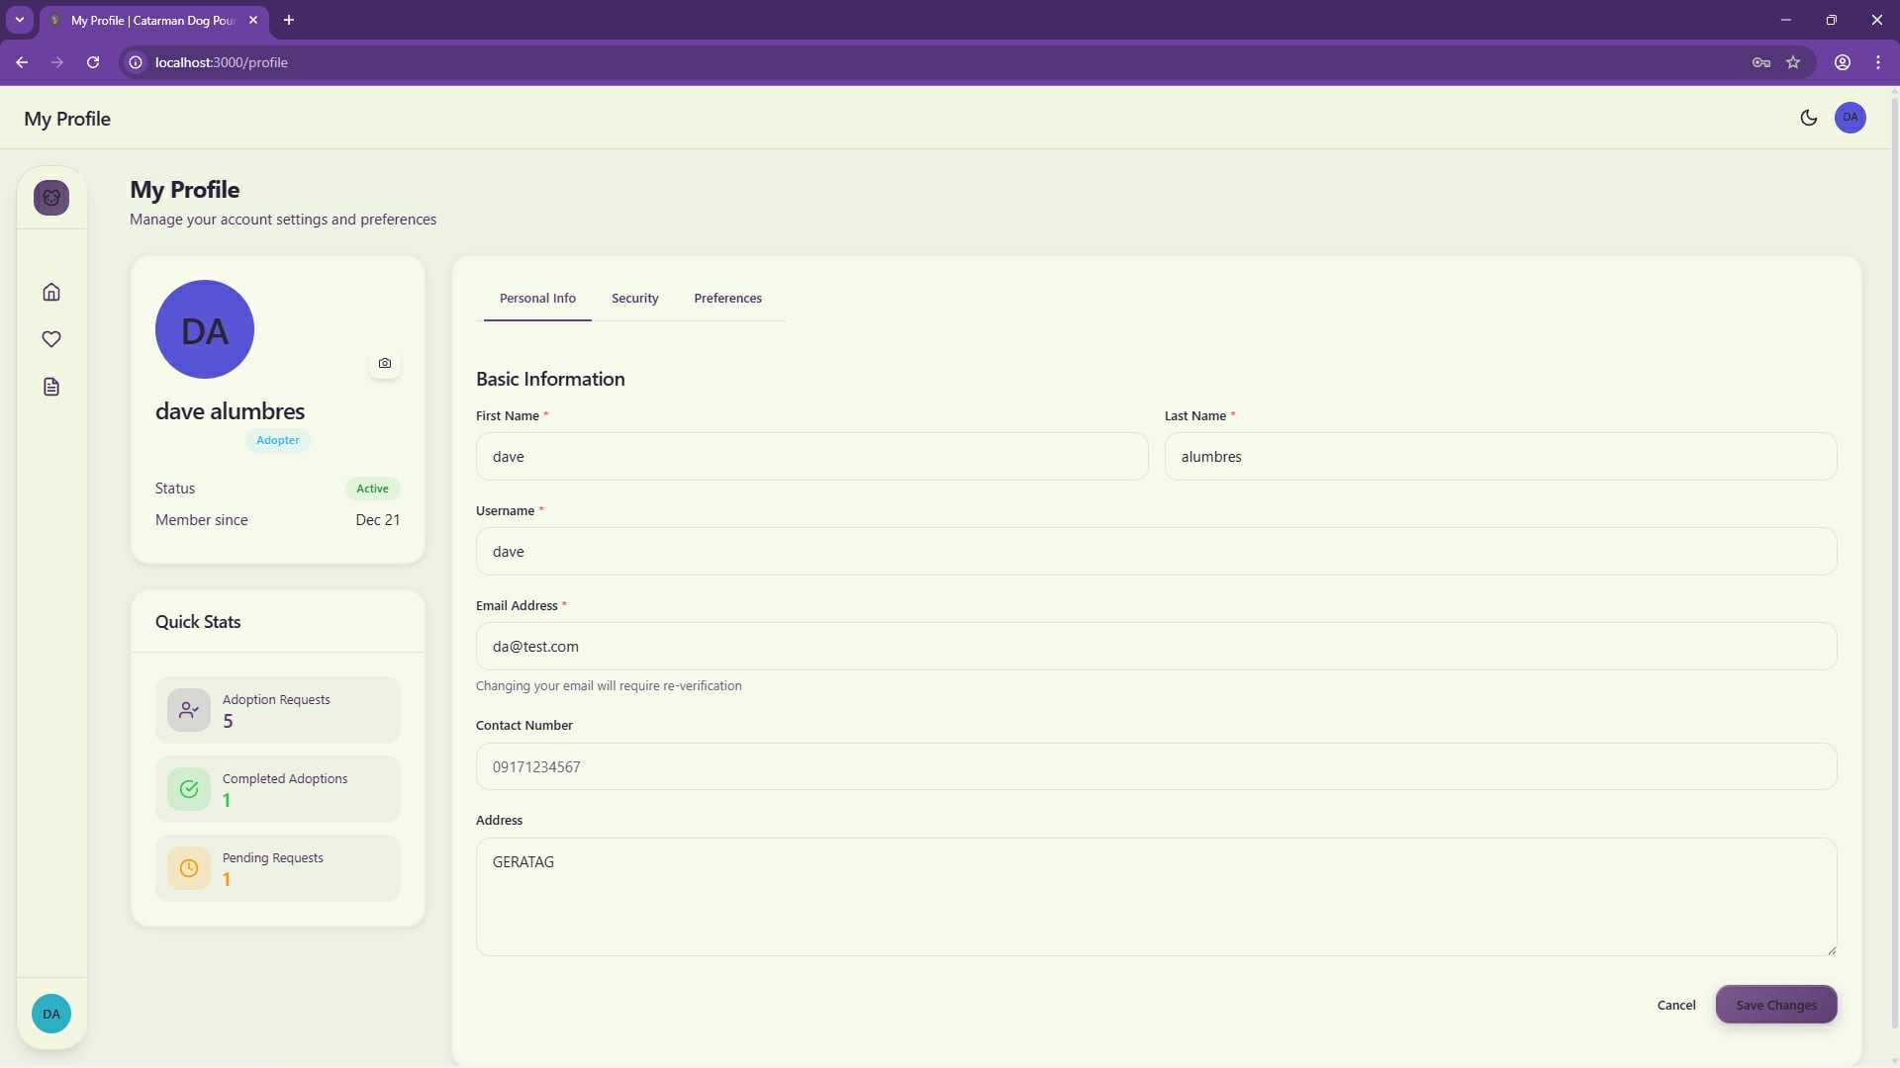

Figure 39: Adopter Profile Page

Data Modeling

Context Data Model
The context data model for the "Catarman Dog Pound & Animal Shelter Management System" outlines how key data, such as users, animals, medical records, inventory, and adoption applications, are interconnected, along with the processes that manage them.

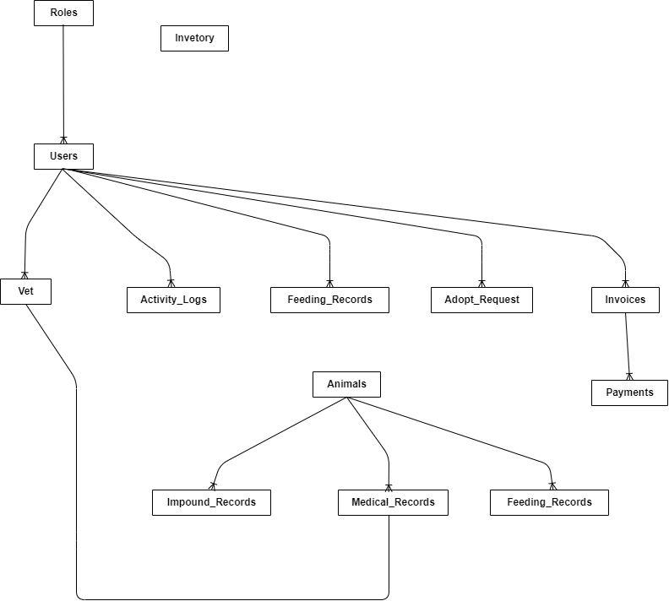

Figure 40: Context Data Model

Key-Based Data Model
The key-based data model for the "Catarman Dog Pound & Animal Shelter Management System" details the tables and their attributes, including primary and foreign keys, to define relationships between entities like users, animals, medical records, inventory, and adoption applications. It shows how data is structured and linked to support all system functionalities.
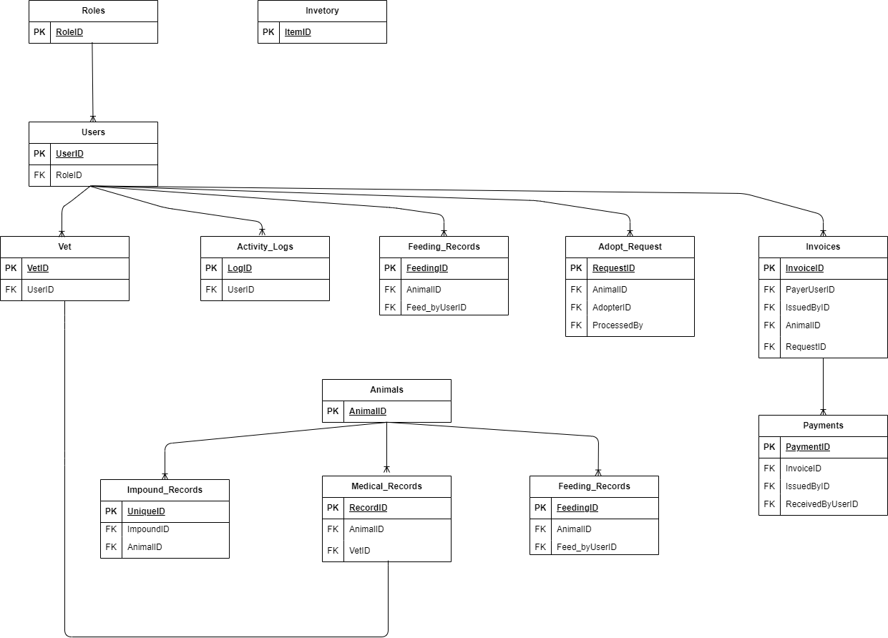

Figure 41: Key-Based Data Model

Fully Attributed Data Model
The fully attributed data model provides a detailed blueprint of the database for the "Catarman Dog Pound & Animal Shelter Management System." It specifies all tables, their attributes with data types and lengths, primary keys, foreign keys, and the precise relationships between entities such as users, animals, medical records, inventory, and adoption applications, including the various management and reporting processes.
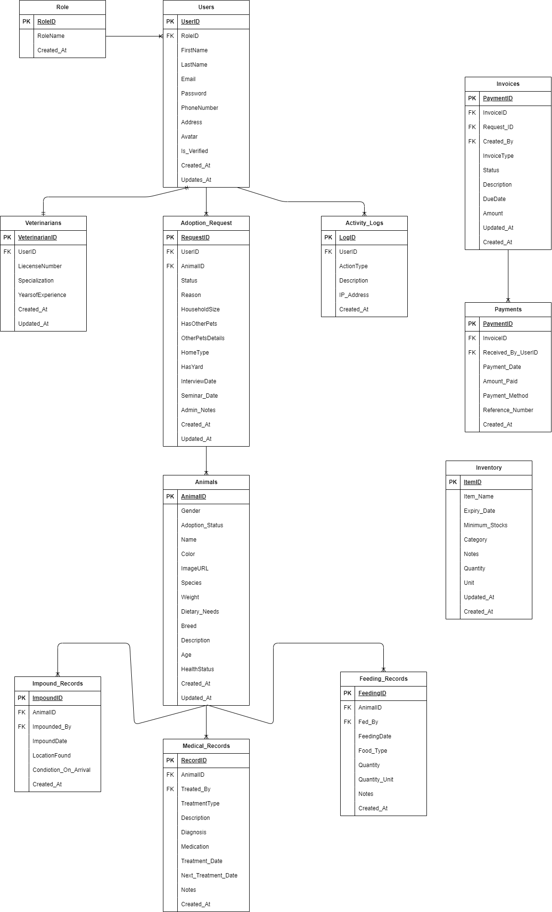

Figure 42: Fully Attributed Data Model

Data Dictionary
This data dictionary provides a clear description of the attributes used in the “Catarman Dog Pound & Animal Shelter Management System”.

Table 6: Roles
Attribute | Data Type | Constraints
RoleID | INT | PK, AUTO_INCREMENT
RoleName | VARCHAR(50) | NOT NULL, UNIQUE
Created_At | DATETIME | DEFAULT CURRENT_TIMESTAMP
Updated_At | DATETIME | ON UPDATE CURRENT  _TIMESTAMP

Table 7: Users
Attribute | Data Type | Constraints
UserID | INT | PK, AUTO INCREMENT
RoleID | INT | FK - Roles(RoleID), NOT NULL
Fname | VARCHAR(50) | NOT NULL
LName | VARCHAR(50) | NOT NULL
Username | VARCHAR(50) | NOT NULL, UNIQUE
Email | VARCHAR(100) | NOT NULL, UNIQUE
Contact Number | VARCHAR(20) | NULLABLE
Address | TEXT | NULLABLE
Avatar_ URL | VARCHAR(255) | NULLABLE
Password Hash | VARCHAR(255) | NOT NULL
Account Status | ENUM | ‘Active’, ‘Inactive’, ‘Banned’
Preferences | JSON | NULLABLE
Is_Deleted | BOOLEAN | DEFAULT FALSE
Created_At | DATETIME | DEFAULT CURRENT_TIMESTAMP
Updated_At | DATETIME | ON UPDATE CURRENT  _TIMESTAMP

Table 8: Veterinarians
Attribute | Data Type | Constraints
VetID | INT | PK, AUTO_INCREMENT
UserID | INT | FK → Users(UserID), NOT NULL, UNIQUE
License_Number | VARCHAR(50) | NOT NULL
Specialization | VARCHAR(100) | NULLABLE
Years_Experience | INT | DEFAULT 0
Clinic_Name | VARCHAR(100) | NULLABLE
Bio | TEXT | NULLABLE
Created_At | DATETIME | DEFAULT CURRENT_TIMESTAMP
Updated_At | DATETIME | ON UPDATE CURRENT_TIMESTAMP

Table 9: Animals
Attribute | Data Type | Constraints
AnimalID | INT | PK, AUTO_INCREMENT .
Name | VARCHAR(50) | NOT NULL
Type | ENUM | 'Dog', 'Cat', 'Other', NOT NULL
Breed | VARCHAR(50) | NULLABLE
Gender | ENUM | 'Male', 'Female', 'Unknown'
Age_Group | VARCHAR(20) | NULLABLE
Weight | DECIMAL(5,2) | NULLABLE
Intake_Date | DATETIME | DEFAULT CURRENT_TIMESTAMP
Intake_Status | ENUM | 'Stray', 'Surrendered', 'Confiscated'
Current_Status | ENUM | 'Available', 'Adopted', 'Deceased', 'In Treatment', 'Quarantine', 'Reclaimed', 'Reserved'
Image_URL | VARCHAR(255) | NULLABLE
Is_Deleted | BOOLEAN | DEFAULT FALSE
Created_At | DATETIME | DEFAULT CURRENT_TIMESTAMP
Updated_At | DATETIME | ON UPDATE CURRENT_TIMESTAMP

Table 10: Impound Records
Attribute | Data Type | Constraints
ImpoundID | INT | PK, AUTO_INCREMENT
AnimalID | INT | FK → Animals(AnimalID), NOT NULL
Capture_Date | DATETIME | NOT NULL
Location_Found | VARCHAR(255) | NOT NULL
Impounding_Officer | VARCHAR(100) | NOT NULL
Condition_On_Arrival | TEXT | NULLABLE
Created_At | DATETIME | DEFAULT CURRENT_TIMESTAMP
Updated_At | DATETIME | ON UPDATE CURRENT_TIMESTAMP

Table 11: Medical Records
Attribute | Data Type | Constraints
RecordID | INT | PK, AUTO_INCREMENT
AnimalID | INT | FK → Animals(AnimalID), NOT NULL
VetID | INT | FK → Veterinarians(VetID), NOT NULL
Date_Performed | DATETIME | DEFAULT CURRENT_TIMESTAMP
Diagnosis_Type | ENUM | 'Checkup', 'Vaccination', 'Surgery','Treatment', 'Emergency', 'Deworming','Spay/Neuter', NOT NULL
Vaccine_Name | VARCHAR(100) | NULLABLE
Treatment_Notes | TEXT | NULLABLE
Next_Due_Date | DATE | NULLABLE
Created_At | DATETIME | DEFAULT CURRENT_TIMESTAMP
Updated_At | DATETIME | ON UPDATE CURRENT_TIMESTAMP

Table 12: Feeding Records
Attribute | Data Type | Constraints
FeedingID | INT | PK, AUTO_INCREMENT
AnimalID | INT | FK → Animals(AnimalID), NOT NULL
Fed_By_UserID | INT | FK → Users(UserID), NOT NULL
Feeding_Time | DATETIME | DEFAULT CURRENT_TIMESTAMP
Quantity_Used | DECIMAL(5,2) | NOT NULL
Food_Type | VARCHAR(50) | NOT NULL
Created_At | DATETIME | DEFAULT CURRENT_TIMESTAMP

Table 13: Adoption Requests
Attribute | Data Type | Constraints
RequestID | INT | PK, AUTO_INCREMENT
AnimalID | INT | FK → Animals(AnimalID), NOT NULL
Adopter_UserID | INT | FK → Users(UserID), NOT NULL
Request_Date | DATETIME | DEFAULT CURRENT_TIMESTAMP
Status | ENUM | 'Pending', 'Interview Scheduled', 'Seminar Scheduled', 'Approved', 'Rejected', 'Completed', 'Cancelled'
Interview_Date | DATETIME | NULLABLE
Seminar_Date | DATETIME | NULLABLE
Staff_Comments | TEXT | NULLABLE
Processed_By_UserID | INT | FK → Users(UserID), NULLABLE
Created_At | DATETIME | DEFAULT CURRENT_TIMESTAMP
Updated_At | DATETIME | ON UPDATE CURRENT_TIMESTAMP

Table 14: Inventory
Attribute | Data Type | Constraints
ItemID | INT | PK, AUTO_INCREMENT
Item_Name | VARCHAR(100) | NOT NULL
Category | ENUM | 'Medical', 'Food', 'Cleaning', 'Supplies', NOT NULL
Quantity_On_Hand | INT | DEFAULT 0
Reorder_Level | INT | DEFAULT 10
Expiration_Date | DATE | NULLABLE
Supplier_Name | VARCHAR(100) | NULLABLE
Last_Updated | DATETIME | ON UPDATE CURRENT_TIMESTAMP
Created_At | DATETIME | DEFAULT CURRENT_TIMESTAMP

Table 15: Invoices

Attribute | Data Type | Constraints
InvoiceID | INT | PK, AUTO_INCREMENT
Payer_UserID | INT | FK → Users(UserID), NOT NULL
Issued_By_UserID | INT | FK → Users(UserID), NOT NULL
Transaction_Type | ENUM | 'Adoption Fee', 'Reclaim Fee'
Total_Amount | DECIMAL(10,2) | NOT NULL
Status | ENUM | 'Unpaid', 'Paid','Cancelled'
Is_Deleted | BOOLEAN | DEFAULT FALSE
Related_AnimalID | INT | FK → Animals(AnimalID), NULLABLE
Related_RequestID | INT | FK → Adoption_Requests, NULLABLE
Created_At | DATETIME | DEFAULT CURRENT_TIMESTAMP
Updated_At | DATETIME | ON UPDATE CURRENT_TIMESTAMP

Table 16:Payments
Attribute | Data Type | Constraints
PaymentID | INT | PK, AUTO_INCREMENT
InvoiceID | INT | FK → Invoices(InvoiceID), NOT NULL
Received_By_UserID | INT | FK → Users(UserID), NOT NULL
Payment_Date | DATETIME | DEFAULT CURRENT_TIMESTAMP
Amount_Paid | DECIMAL(10,2) | NOT NULL
Payment_Method | ENUM | 'Cash', 'GCash', 'Bank Transfer'
Reference_Number | VARCHAR(50) | NULLABLE
Created_At | DATETIME | DEFAULT CURRENT_TIMESTAMP

Table 17: Activity Logs
Attribute | Data Type | Constraints
LogID | INT | PK, AUTO_INCREMENT
UserID | INT | FK → Users(UserID), NULLABLE
Action_Type | VARCHAR(50) | NOT NULL
Description | TEXT | NOT NULL
IP_Address | VARCHAR(45) | NULLABLE
Created_At | DATETIME | DEFAULT CURRENT_TIMESTAMP

CHAPTER IV

System Implementation and Unit Testing

Implementation
The implementation phase involved the translation of the system design into a functional application. The Catarman Dog Pound & Animal Shelter Management System (CDP&ASMS) was developed to replace the traditional manual and paper-based processes with a digital, automated solution deployed as a comprehensive web-based application.
Software Specification
The system was developed using modern, widely supported web technologies to ensure reliability, scalability, and ease of maintenance. The table below presents the software requirements used in implementing the system.
Software Requirements:
Component | Specification
Operating System | Windows 11
Web Server | Apache (via XAMPP)
Database Management System | MySQL 8.0
Programming Languages | HTML5, CSS3, JavaScript, PHP
Development Tools | Visual Studio Code
Web Browser | Google Chrome (Latest Version)

Table 18: Software Requirements
These software tools enabled efficient development, testing, and deployment of the system while ensuring cross-browser compatibility and secure data handling.

Hardware Specification
The system was implemented and tested using the following hardware specifications to ensure smooth operation:
Minimum Requirements:
Component | Specification
Processor | Intel Core i5 10th Gen
RAM | 8 GB
Storage | 256 GB SSD

Table 19: Minimum Requirements
Recommended Requirements:
Component | Specification
Processor | Intel Core i5 10th Gen
RAM | 16 GB
Storage | 512 GB SSD

Table 20: Recommended Requirements
These specifications ensured stable system performance during development and testing phases.

Program Specification
The Catarman Dog Pound & Animal Shelter Management System is a web-based application composed of several interconnected modules designed to handle shelter operations efficiently. The major system modules include:
- User Management Module – Handles registration, login, role-based access control, and profile management.
- Animal Management Module – Manages animal intake, profile updates, status tracking, and adoption availability.
- Medical Records Module – Enables veterinarians to record treatments, vaccinations, and health histories.
- Adoption Management Module – Processes adoption requests, interviews, approvals, and completion.
- Inventory Module – Tracks food, medicines, and supplies with stock monitoring.
- Billing and Payment Module – Generates invoices and records payments.
- Reports and Logs Module – Generates system reports and maintains audit logs for accountability.
Each module was developed using structured programming practices and integrated through a centralized MySQL database.

Programming Environment

Front-End
The front-end of the system was developed using:
- HTML5 for page structure and content
- CSS3 for layout design and responsiveness
- JavaScript for dynamic behavior, form validation, and user interaction
The interface was designed to be user-friendly, responsive, and accessible across different devices.

Back-End
The back-end was implemented using:
- PHP for server-side logic, data processing, and system control
- MySQL for relational database management
- PDO (PHP Data Objects) for secure database connections and queries
The back-end handles authentication, data validation, CRUD operations, and business logic

Deployment Diagram
The system follows a client-server architecture. Users access the system through a web browser, which communicates with the Apache web server. The PHP application processes requests and interacts with the MySQL database to retrieve or store data. This architecture ensures centralized data management, improved security, and easier maintenance.

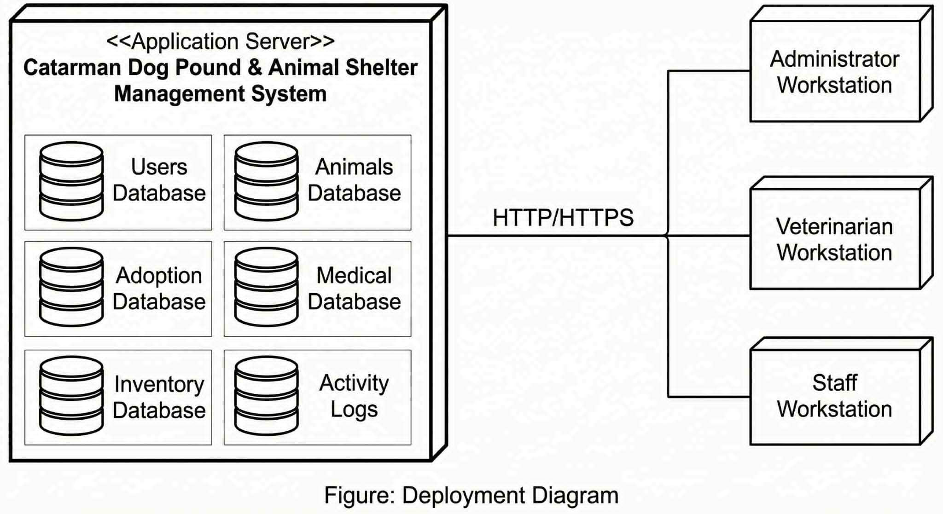Figure 43: Deployment Diagram

Implementation Plan
The system was implemented following the Waterfall Development Model, as outlined in Chapter III. The implementation phases included:
- Requirement Analysis – Reviewing documented system requirements
- System Design – Translating designs into system modules
- Coding and Development – Writing front-end and back-end code
- Integration – Connecting modules to the database
- Testing – Conducting unit and functional testing
- Deployment – Preparing the system for actual use
Each phase was completed sequentially to ensure correctness and completeness.

Unit Testing
Rating Scale
Points | Range | Interpretation
5 | 4.5 – 5.0 | Highly Acceptable – The system is highly acceptable to users. It works well and meets all or most of their needs with very few or no usability.
4 | 4.0 – 4.4 | Acceptable – It works well and meets most of their needs, but there may still be some room for improvements.
3 | 3.5 – 3.9 | Moderately Acceptable – It generally works well but some usability issues can be improved.
2 | 3.0 – 3.4 | Slightly Acceptable – The system is somewhat acceptable to users, but it has noticeable flaws and usability issues that could be improved.
1 | Below 3.0 | Not Acceptable – It has significant flaws and usability issues that make it difficult or impossible to use effectively.

Table 21: Rating Scale

Component | 1 | 2 | 3 | 4 | 5 | Weighted Mean | Remark
Performance
The system responds quickly to user requests (page loads, form submissions). |  |  |  |  | ✓ | 5 | Highly Acceptable
There are no noticeable delays when loading animal records or medical histories. |  |  |  | ✓ |  | 4 | Acceptable
Staff can process adoption requests (from submission to completion) quickly. |  |  |  |  | ✓ | 5 | Highly Acceptable
The dashboard loads statistics and charts within an acceptable time frame (< 3 seconds). |  |  |  |  | ✓ | 5 | Highly Acceptable
The system handles concurrent users without performance degradation. |  |  |  |  | ✓ | 5 | Highly Acceptable
The system performs well even when handling large datasets (e.g., 1000+ records). |  |  |  |  | ✓ | 5 | Highly Acceptable
PDF exports (medical records, reports) are generated quickly. |  |  |  |  | ✓ | 5 | Highly Acceptable
The system is reliable and rarely experiences downtime or crashes. |  |  |  |  | ✓ | 5 | Highly Acceptable
Total Weighted Mean |  |  |  |  |  | 4.8 | Highly Acceptable

Table 22: Testing the level of acceptability in terms of Performance
Table 22 presents the level of acceptability of the system in terms of performance, which obtained a total weighted mean of 4.8, interpreted as Highly Acceptable. This result indicates that the system performs efficiently and reliably during actual use. Respondents observed that the system responds quickly to user requests such as page loading, form submissions, and record retrieval. Core processes, including adoption request handling, dashboard loading, PDF generation, and management of large datasets, were executed smoothly with minimal delays. Furthermore, the system was able to handle multiple concurrent users without performance degradation and exhibited stable operation with rare instances of downtime or crashes. Overall, the findings confirm that the system meets the performance requirements and is dependable for its intended application.

Component | 1 | 2 | 3 | 4 | 5 | Weighted Mean | Remark
Information
Animal records (name, breed, status, medical history) are consistently accurate. |  |  |  |  | ✓ | 5 | Highly Acceptable
Adoption request statuses reflect real-time updates (Pending → Approved). |  |  |  |  | ✓ | 5 | Highly Acceptable
Inventory quantities and low-stock alerts are accurate and reliable. |  |  |  |  | ✓ | 5 | Highly Acceptable
The dashboard displays current statistics and activity logs without lag. |  |  |  |  | ✓ | 5 | Highly Acceptable
Medical record overdue notifications are displayed promptly. |  |  |  |  | ✓ | 5 | Highly Acceptable
Each user role sees only the information relevant to their responsibilities. |  |  |  |  | ✓ | 5 | Highly Acceptable
Search and filter options are adequate for finding specific records. |  |  |  |  | ✓ | 5 | Highly Acceptable
Information is presented in a clear, easy-to-read format on both desktop and mobile. |  |  |  |  | ✓ | 5 | Highly Acceptable
Total Weighted Mean |  |  |  |  |  | 5 | Highly Acceptable

Table 23: : Testing the level of acceptability in terms of Information
As shown in Table 23, the system’s level of acceptability in terms of information achieved a total weighted mean of 5.0, which is interpreted as Highly Acceptable. This indicates that the system provides accurate, timely, and relevant information to its users. Respondents agreed that animal records, adoption statuses, inventory data, and medical histories are consistently accurate and updated in real time. Additionally, the dashboard displays current statistics and activity logs without noticeable lag, while notifications such as overdue medical records are shown promptly. The results further demonstrate that role-based access ensures users see only information relevant to their responsibilities. Overall, the system effectively supports informed decision-making through clear, reliable, and well-organized information presentation.

Component | 1 | 2 | 3 | 4 | 5 | Weighted Mean | Remark
Efficiency
Common tasks (e.g., registering an animal) require minimal steps. |  |  |  |  | ✓ | 5 | Highly Acceptable
The system avoids unnecessary duplicate data entry points. |  |  |  |  | ✓ | 5 | Highly Acceptable
The system automates repetitive tasks (e.g., status updates, notifications). |  |  |  |  | ✓ | 5 | Highly Acceptable
Staff can complete daily tasks faster with the system than with manual methods. |  |  |  |  | ✓ | 5 | Highly Acceptable
The interface is intuitive for new users with minimal training. |  |  |  |  | ✓ | 5 | Highly Acceptable
Frequently used features are easily accessible (e.g., dashboard shortcuts). |  |  |  |  | ✓ | 5 | Highly Acceptable
The system integrates well with existing shelter workflows. |  |  |  | ✓ |  | 4 | Acceptable
Total Weighted Mean |  |  |  |  |  | 4.8 | Highly Acceptable

Table 24: Testing the level of acceptability in terms of Efficiency
Table 24 shows that the system obtained a total weighted mean of 4.8, verbally interpreted as Highly Acceptable in terms of efficiency. This result suggests that the system significantly improves task completion speed and workflow efficiency. Respondents noted that common tasks such as registering animals and managing records require minimal steps and avoid unnecessary duplication of data entry. The system also automates repetitive processes, including status updates and notifications, which helps staff complete daily tasks faster compared to manual methods. Although integration with existing shelter workflows received a slightly lower rating, it remained acceptable. Overall, the system enhances operational efficiency and supports productive use with minimal training requirements.

Component | 1 | 2 | 3 | 4 | 5 | Weighted Mean | Remark
Control and Security
User passwords and authentication (Login) are secure. |  |  |  |  | ✓ | 5 | Highly Acceptable
Rate limits effectively prevent brute force login attempts. |  |  |  | ✓ |  | 4 | Acceptable
Role-based permissions effectively restrict unauthorized access to data. |  |  |  |  | ✓ | 5 | Highly Acceptable
Users can only view and modify records appropriate to their role. |  |  |  |  | ✓ | 5 | Highly Acceptable
Administrative functions (e.g., deletions) are strictly restricted to Admins. |  |  |  |  | ✓ | 5 | Highly Acceptable
The system maintains an audit trail (activity logs) for significant actions. |  |  |  |  | ✓ | 5 | Highly Acceptable
Data validation rules are consistently applied (preventing invalid data entry). |  |  |  |  | ✓ | 5 | Highly Acceptable
Total Weighted Mean |  |  |  |  |  | 4.8 | Highly Acceptable

Table 25: Testing the level of acceptability in terms of Control and Security
Based on Table 25, the system’s control and security features achieved a total weighted mean of 4.8, interpreted as Highly Acceptable. This indicates that the system effectively safeguards data and enforces appropriate access controls. Users agreed that authentication mechanisms, such as secure login and password protection, are reliable, while role-based permissions successfully restrict unauthorized access to sensitive information. Administrative functions are limited to authorized personnel, and audit trails are maintained to track significant system activities. Although rate-limiting mechanisms received a slightly lower rating, they were still deemed acceptable. Overall, the results confirm that the system provides a secure and well-controlled environment for managing records and operations.

Component | 1 | 2 | 3 | 4 | 5 | Weighted Mean | Remark
Economics (Cost-Effectiveness)
The system eliminates costs associated with paper forms and manual processes. |  |  |  |  | ✓ | 5 | Highly Acceptable
The system saves significant time compared to manual paper-based processes. |  |  |  |  | ✓ | 5 | Highly Acceptable
The system helps avoid financial losses (e.g., missed medical treatments, expired inventory). |  |  |  |  | ✓ | 5 | Highly Acceptable
Adoption processing time has decreased since implementing the system. |  |  |  |  | ✓ | 5 | Highly Acceptable
The system improves overall operational efficiency enough to justify its implementation. |  |  |  |  | ✓ | 5 | Highly Acceptable
Total Weighted Mean |  |  |  |  |  | 5 | Highly Acceptable

Table 26: Testing the level of acceptability in terms of Economics
Table 26 presents the level of acceptability of the system in terms of economics, which yielded a total weighted mean of 5.0, verbally interpreted as Highly Acceptable. This finding indicates that the system is highly cost-effective and provides substantial operational benefits. Respondents agreed that the system eliminates costs associated with paper-based processes and significantly reduces the time required to perform routine tasks. Additionally, the system helps prevent financial losses related to missed medical treatments and expired inventory. The reduction in adoption processing time further demonstrates its economic value. Overall, the system justifies its implementation by improving efficiency while minimizing operational costs.

Component | 1 | 2 | 3 | 4 | 5 | Weighted Mean | Remark
Services (User Experience & Satisfaction)
Users are satisfied with the system's overall ease of use. |  |  |  | ✓ |  | 4 | Acceptable
The interface is visually appealing and modern. |  |  |  |  | ✓ | 5 | Highly Acceptable
Users can complete tasks without frustration or confusion. |  |  |  | ✓ |  | 4 | Acceptable
The system is accessible to users with different needs (readable text, clear contrast). |  |  |  | ✓ |  | 4 | Acceptable
Error messages are helpful and guide users toward the correct action. |  |  |  |  | ✓ | 5 | Highly Acceptable
The system performs consistently across different browsers and devices. |  |  |  | ✓ |  | 4 | Acceptable
I am satisfied with the overall services and features of the system. |  |  |  | ✓ |  | 4 | Acceptable
Total Weighted Mean |  |  |  |  |  | 4.2 | Acceptable

Table 27: Testing the level of acceptability in terms of Services
As reflected in Table 27, the system achieved a total weighted mean of 4.2, which is interpreted as Acceptable in terms of services and user experience. This suggests that users are generally satisfied with the system, though there is room for further improvement. Respondents found the interface visually appealing and modern, and error messages were considered helpful in guiding users toward correct actions. However, some aspects such as accessibility, ease of completing tasks without confusion, and consistency across devices received slightly lower ratings. Despite these areas for enhancement, users expressed overall satisfaction with the system’s services and features. The results indicate that the system delivers a positive user experience while presenting opportunities for future refinements.

CHAPTER V

Summary, Conclusions and Recommendations

Summary
This study focused on the design, development, and implementation of the Catarman Dog Pound & Animal Shelter Management System (CDP&ASMS), a web-based information system intended to modernize and improve the operational efficiency of the Catarman Dog Pound and Animal Birth Control Center. The project was undertaken in response to the identified challenges associated with manual record-keeping, fragmented data storage, and inefficient coordination among shelter personnel, veterinarians, and adopters.
Guided by the objectives presented in Chapter I, the system was designed to provide a centralized platform for managing animal records, medical histories, adoption processes, inventory, billing, and user activities. The system architecture was carefully planned and implemented using industry-standard web technologies, including HTML, CSS, JavaScript, PHP, and MySQL, ensuring reliability, security, and accessibility.
Specifically, the system achieved its general objective of streamlining shelter operations by automating routine administrative tasks and consolidating all relevant data into a single database. The specific objectives were likewise met through the successful implementation of role-based access control, comprehensive animal and user profile management, medical record tracking, inventory monitoring, billing and payment recording, and activity logging.
Through systematic testing and evaluation, the system demonstrated its capability to improve record accuracy, reduce processing time, and support data-driven decision-making. Overall, the development of the CDP&ASMS provides a practical and effective technological solution that addresses the operational needs of the Catarman Dog Pound while promoting improved animal welfare and responsible pet ownership.

Conclusions
Based on the development, implementation, and testing of the Catarman Dog Pound & Animal Shelter Management System, the following conclusions were drawn:
First, the system successfully replaced the traditional manual and paper-based processes previously used by the shelter. By centralizing animal, medical, adoption, inventory, and financial records, the system significantly reduced data redundancy, inconsistencies, and the risk of information loss. This improvement in data management enhanced the accuracy, accessibility, and reliability of shelter records.
Second, implementing role-based access control proved effective in maintaining system security and accountability. Administrators, staff members, veterinarians, and adopters were granted access only to the functions relevant to their roles. This ensured proper data confidentiality while allowing users to perform their designated tasks efficiently. The inclusion of activity logs further strengthened accountability by recording user actions and system events.
Third, the adoption management workflow streamlined the entire adoption process, from application submission to approval and completion. The system enabled shelter staff to monitor adoption requests more efficiently, schedule interviews and seminars, and maintain proper documentation. This resulted in a more organized and transparent adoption process that benefits both shelter personnel and adopters.
Fourth, integrating inventory, billing and payment modules improved operational oversight and financial management. The system provided real-time visibility of supply levels, facilitated invoice generation, and ensured accurate payment tracking. These features contributed to better resource utilization and financial transparency within the shelter.
Lastly, based on system testing and user evaluation, the CDP&ASMS was found to be functional, user-friendly, and responsive. The system met performance expectations in terms of speed, reliability, and ease of use. These findings indicate that the system is suitable for actual deployment and daily use in the Catarman Dog Pound and Animal Birth Control Center.
In conclusion, the Catarman Dog Pound & Animal Shelter Management System effectively addressed the problems identified in this study and achieved its intended objectives, demonstrating that web-based solutions can significantly improve public service operations in animal welfare management.

Recommendations

Real-Time Notifications
It is recommended that future versions of the system include real-time notification features to immediately inform users of important system updates such as adoption request status changes, medical schedules, inventory alerts, and administrative announcements. Real-time notifications would improve responsiveness, reduce delays in decision-making, and ensure that critical information is promptly communicated to shelter staff, veterinarians, and adopters.

SMS Support
The integration of SMS support is recommended to provide an alternative communication channel for users who may have limited or unreliable internet access. SMS notifications can be used for adoption confirmations, appointment reminders, and emergency alerts, thereby improving accessibility and inclusivity, particularly for community members in remote areas.

GPS Tracking
Future development of the system may include GPS tracking functionality to support real-time location monitoring of animals during rescue operations, transfers, or temporary releases. GPS tracking would enhance field operation efficiency, improve accountability, and help ensure the safety and proper handling of animals outside the shelter premises.

Embedded Systems for Animal Tracking
It is recommended to integrate embedded systems such as RFID tags or sensor-based devices to enable automated tracking of animals within and outside the shelter. These systems can assist in monitoring movement, health indicators, and shelter capacity, reducing reliance on manual tracking and improving accuracy in animal management.

Mobile Application Development
Developing a dedicated mobile application is recommended to improve system accessibility and usability. A mobile app would allow shelter staff, veterinarians, and adopters to perform essential tasks such as viewing animal profiles, submitting adoption requests, and receiving updates conveniently through smartphones, thereby increasing user engagement and operational efficiency.

AI-Based Food Intake Suggestions
The system may be enhanced by incorporating artificial intelligence to provide recommended food intake and care plans based on an animal’s age, weight, breed, and medical condition. AI-driven suggestions would support better nutritional management, promote animal health, and assist staff in making informed care decisions.

Expansion to Other LGUs
It is recommended that the system be expanded and adapted for use by other Local Government Units (LGUs) to promote standardized and efficient animal shelter management practices. System expansion would allow broader implementation, improve inter-LGU coordination, and contribute to nationwide efforts in animal welfare and responsible pet ownership.

